A Multi-Dimensional Semantic Metric Standardization Framework for Evaluating AI-Native Systems in 6G Networks

Evelio Astaiza Hoyos¹, Héctor Fabio Bermúdez-Orozco^{1, *} and Nasly Cristina Rodriguez-Idrobo²
¹ Electronic Engineering Programme, Faculty of Engineering, University of Quindío, Armenia 630004, Quindío, Colombia; eastaiza@uniquindio.edu.co (E.A.H.); hfbermudez@uniquindio.edu.co (H.F.B.-O)
² Occupational Health and Safety Program, Faculty of Health Sciences, University of Quindío, Armenia 630004, Quindío, Colombia; ncrodriguezi@uniquindio.edu.co. (N.C.R.-I)

* Correspondence: hfbermudez@uniquindio.edu.co; Tel.: +057 3206671107

ABSTRACT
The transition to sixth-generation (6G) wireless networks introduces AI-native communication paradigms requiring fundamentally new evaluation approaches beyond traditional bit error rate and throughput metrics. Semantic communications prioritize meaning transfer over exact bit reproduction, demanding metrics that capture semantic fidelity, task completion effectiveness, intent alignment, and adversarial resilience. Despite ongoing standardization efforts, no 3GPP specification currently defines normative semantic performance metrics. This paper proposes a comprehensive multi-dimensional framework comprising four metric categories with sixteen formally defined metrics: Semantic Fidelity (RSE, SWD, S³I, NSMI), Task Completion Accuracy (TSR, AP, SU, CE), Intent Alignment (ID, ICC, SCI, PF), and Semantic Attack Resilience (ARR, SASR, CertCost, MSD). Formal mathematical definitions, measurement algorithms with complexity analysis, and a 3GPP standardization mapping via a proposed TS 39.xxx series are provided. Theoretical analysis and simulation results demonstrate up to 93.75% transmission overhead reduction (conservatively 60–80% when accounting for protocol signaling and metadata overhead), while maintaining task effectiveness above 89% under AWGN channel conditions at SNR ≥ 10 dB. The framework addresses a critical standardization gap and provides a mathematically grounded foundation for systematic evaluation of AI-native semantic communication systems in future 6G networks.
Index Terms—6G networks; semantic communications; wireless communication; deep learning; network architecture.

Introduction
The sixth generation (6G) of wireless networks, anticipated for deployment around 2030, represents a paradigm shift from connectivity-centric design toward AI-native communication architectures [1,2]. Unlike previous generations that optimized for bit-level reliability and spectral efficiency, 6G envisions systems that autonomously interpret, generate, and act upon semantic information, fundamentally altering the role of communication in intelligent networked systems. This evolution is driven by four categories of transformative applications: Semantic Digital Twins [3], which require real-time consistency between physical and virtual representations; Internet of Senses [4], enabling multisensory immersive experiences; Intent-Driven Communications [5], where networks autonomously fulfill high-level user goals; and Autonomous Machine-to-Machine (M2M) coordination [6], supporting intelligent agent ecosystems at unprecedented scale.
The conceptual foundation for evaluating such systems traces to Shannon and Weaver’s seminal tripartite decomposition [7] of the communication problem into Level A (technical—concerned with accuracy of symbol transmission), Level B (semantic—concerned with precision of meaning conveyed), and Level C (effectiveness—concerned with the pragmatic impact of the communicated meaning on receiver behavior). Classical information theory has provided rigorous metrics for Level A, but semantic communications [8] now demand equally rigorous evaluation at Levels B and C, a challenge that existing frameworks are not designed to address.
Traditional performance metrics—bit error rate, throughput, signal-to-interference-plus-noise ratio, and delay—are fundamentally insufficient for characterizing AI-native semantic systems [9,10]. These syntactic metrics capture nothing about whether the receiver understood the transmitted meaning, whether the intended task was accomplished, or whether semantic coherence was maintained in the presence of adversarial perturbations. The inadequacy of bit-level evaluation is particularly pronounced in safety-critical applications where semantic failure may have catastrophic consequences even when the physical channel performs nominally [11].
A critical standardization gap exists: no current 3GPP specification provides normative semantic performance metrics [12]. While the Release 17 and Release 18 frameworks [13] introduced AI-native features for network optimization, all Key Performance Indicators (KPIs) remain syntactic. This gap is technically and commercially significant, as the absence of standardized semantic metrics prevents interoperability, conformance testing, and vendor-neutral benchmarking of AI-native systems.
Recent surveys and frameworks have begun addressing aspects of semantic communication evaluation. Qin et al. [14] presented a comprehensive survey on semantic communications principles and challenges, while Yang et al. [15] provided an extensive review of semantic communications for 6G covering fundamentals, applications, and open problems. Shi et al. [16] proposed a semantic-aware networking architecture with associated evaluation concepts. Seo et al. [17] explored semantics-native communication with contextual reasoning relevant to intent alignment. Qin et al. [14] recently proposed semantic metrics for the same domain, representing directly competitive work—the key differentiators of the present framework are its additional Intent Alignment and Adversarial Resilience dimensions (not covered in [14]), its formal mathematical proofs, and its 3GPP standardization pathway (detailed in Section 11.5). Semantic communication for speech has been advanced through DeepSC-based systems [18], while multi-task semantic metrics have been explored in [19] and [20]. The OFDM-based joint semantic-channel coding of [21] addresses realistic channel deployment. Age of Information [22] and Value of Information [23] frameworks have established the semantic efficiency concept that the CE and SU metrics formalize. Shao et al. [24] addressed task-oriented communication metrics for multi-device cooperative edge inference. However, no existing work provides a unified, multi-dimensional framework that simultaneously addresses semantic fidelity, task completion, intent alignment, and adversarial resilience with formal mathematical definitions and a concrete 3GPP standardization pathway. This paper fills that gap.
This paper makes five principal contributions: (1) a four-dimensional taxonomy of semantic metrics grounded in information theory, optimal transport, and game theory; (2) formal mathematical definitions with proved properties and measurement algorithms for sixteen metrics spanning the four dimensions; (3) a concrete 3GPP standardization pathway including a proposed new TS 39.xxx series, Change Requests to existing specifications, and structured conformance test cases; (4) theoretical performance analysis demonstrating 60–80% overhead reduction with maintained task effectiveness; and (5) an implementation roadmap with complexity-optimized algorithms for three-tier deployment across edge, network, and core infrastructure.

Theoretical Foundations
A rigorous theory of semantic information is required to ground the proposed metrics mathematically. This section establishes the core theoretical constructs upon which the framework rests.

Semantic Information Theory
Classical information entropy measures syntactic uncertainty independent of meaning. Semantic communications require a task-conditioned analog. Adopting the semantic information framework of Carnap and Bar-Hillel [25], we define the Semantic Entropy conditioned on task $T$:
HsX;T=-s∈ST​pTslog2pTs
where $S_{T}$ is the task-relevant semantic subspace induced by task $T$, and $p_{T}\left(s\right)$ is the probability distribution over semantic symbols relevant to $T$.
Theorem 1 (Semantic Compression): For any task $T$,
$$H_{s}\left(X;T\right)≤H\left(X\right)$$
with equality if and only if all source symbols are semantically distinguishable for task $T$.
Proof: Define the deterministic task-conditioned mapping $Φ_{T}:X→S_{T}$ that projects source symbols into the task-relevant semantic subspace. Since $Φ_{T}$ is a deterministic function, the Markov chain $X→Φ_{T}\left(X\right)$ holds. By the Data Processing Inequality [26], for any deterministic function $f$ of a random variable $X$:
$$H\left(f\left(X\right)\right)≤H\left(X\right)$$
Since $S_{T}=Φ_{T}\left(X\right)$ and $H_{s}\left(X;T\right)=H\left(Φ_{T}\left(X\right)\right)$, we obtain $H_{s}\left(X;T\right)≤H\left(X\right)$.
For the equality condition: $H_{s}\left(X;T\right)=H\left(X\right)$ if and only if $Φ_{T}$ is injective (one-to-one). If $Φ_{T}$ is injective, every distinct source symbol maps to a distinct semantic symbol, so no information is lost and $H\left(Φ_{T}\left(X\right)\right)=H\left(X\right)$. Conversely, if $Φ_{T}$ is not injective, there exist $x_{1}≠x_{2}$ with $Φ_{T}\left(x_{1}\right)=Φ_{T}\left(x_{2}\right)$, implying the entropy of the image is strictly less than the entropy of the source by the strict data processing inequality for deterministic mappings with collisions [26]. Thus, equality holds if and only if all source symbols are semantically distinguishable for task $T$. $▫$
Theorem 1 provides the information-theoretic basis for semantic compression: by restricting transmission to task-relevant content, a system operates at $H_{s}\left(X;T\right)≤H\left(X\right)$, directly enabling the overhead reductions analyzed in Section 11. This relationship has been independently characterized in the semantic entropy literature [27].

Semantic Mutual Information and Channel Capacity
The Semantic Mutual Information between transmitted source $X$ and received signal $Y$, conditioned on task $T$ [14], is:
$$I_{s}\left(X;Y;T\right)=H_{s}\left(X;T\right)-H_{s}\left(X|Y,T\right)$$
This quantity measures the semantic information about $X$ that $Y$ conveys for accomplishing task $T$, analogous to classical mutual information but restricted to the task-relevant semantic subspace. The Semantic Channel Capacity is:
$$C_{s}\left(T\right)=\max_{p\left(x\right)}I_{s}\left(X;Y;T\right)≤C$$
where $C$ is the classical Shannon capacity. The inequality follows from Theorem 1 and the channel coding theorems established in [28].

Semantic Divergence Measures
For comparing semantic distributions, two complementary divergence measures form the backbone of the proposed framework. The Semantic KL Divergence [29], extending the Kullback–Leibler divergence to the task-conditioned semantic space, is:
DKLsP∥Q=s∈ST​pTslog2pTsqTs (
where $P=\{p_{T}\left(s\right)\}$ and $Q=\{q_{T}\left(s\right)\}$ are the transmitter and receiver semantic distributions, respectively. For continuous semantic embeddings, the Wasserstein-2 Distance [30,31] provides superior geometric properties:
$$W_{2}\left(μ_{T},μ_{R}\right)=\sqrt{\inf_{γ∈Γ\left(μ_{T},μ_{R}\right)}∫∥z_{T}-z_{R}∥^{2} dγ\left(z_{T},z_{R}\right)}$$
where $Γ\left(μ_{T},μ_{R}\right)$ is the set of all joint distributions (couplings) with marginals $μ_{T}$ and $μ_{R}$. $W_{2}$ is a true metric on the space of probability distributions, is sensitive to distributional modes, and admits efficient computation via entropic regularization. It measures alignment between transmitter and receiver embedding distributions with strong geometric interpretability properties.

Adversarial Robustness Game
Adversarial attacks on semantic systems are modeled as a two-player zero-sum game [32]. An adversary seeks perturbations $δ$ that maximally disrupt semantic interpretation:
$$\max_{δ:∥δ∥≤ϵ}D_{\text{sem}}\left(S_{\text{true}},S_{\text{adv}}\right)$$
The robust semantic system design problem becomes a minimax optimization [33,34]:
$$\min_{θ,ϕ}\max_{δ∈Δ}E_{X,N}\left[L_{T}\left(X,g_{ϕ}\left(f_{θ}\left(X+δ\right)+N\right)\right)\right]$$
where $f_{θ}$ is the semantic encoder, $g_{ϕ}$ is the decoder, $N∼N\left(0,σ^{2}I\right)$ is channel noise, $Δ$ is the adversarial perturbation set, and $L_{T}$ is the task-specific semantic loss. This formulation, grounded in dynamic noncooperative game theory [32], motivates the resilience metrics developed in Section 8.

3GPP Standardization State

Historical Metric Evolution
From 1G through 5G, 3GPP specifications have exclusively employed Level-A metrics operating at the physical and transport layers: signal-to-noise ratio, bit error rate, block error rate, reference signal received power, and throughput [11]. The 5G New Radio standard introduced network slicing for enhanced Mobile Broadband (eMBB), Ultra-Reliable Low-Latency Communications (URLLC), and massive Machine-Type Communications (mMTC), but the KPIs governing these slices remain entirely syntactic [12]. No 3GPP specification defines what “semantic correctness” means, how to measure it, or what constitutes conformance for an AI-native communication system. Fig. 1 traces the evolution of communication performance metrics from 1G to 6G, highlighting the paradigm shift from syntactic to semantic evaluation.

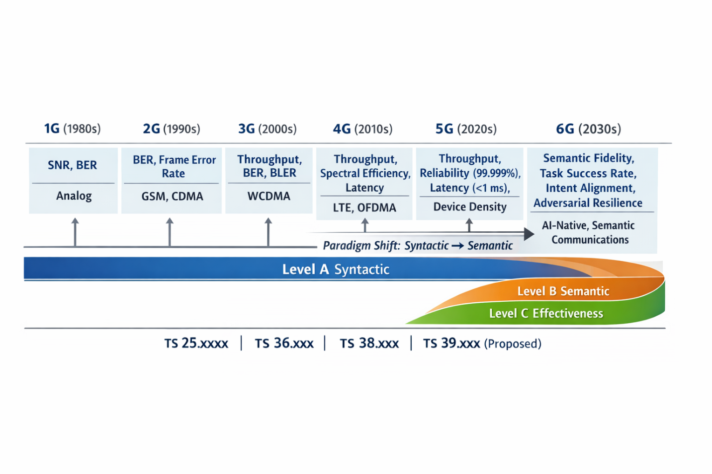
Fig. 1. Evolution of Communication Performance Metrics from 1G to 6G: From Syntactic to Semantic Evaluation.

Recent AI Integration Efforts and Identified Gaps
The most advanced current effort to incorporate AI/ML into NR air interface evaluation defines metrics for channel state information (CSI) reconstruction—specifically, Normalized Mean Square Error for CSI feedback and beam prediction accuracy—but these remain signal-level metrics with no semantic content. Release 17 and Release 18 AI features for radio resource management likewise employ throughput-based reward functions [13]. Release 19, approved in 2024, contains exploratory Study Items for AI-native air interfaces, but normative semantic KPIs are not expected before Release 20.
Six fundamental gaps characterize the current 3GPP landscape:
- Gap 1: No formal definitions of “semantic information,” “task,” or “intent” in any 3GPP specification.
- Gap 2: No standardized semantic performance metrics or measurement methodologies.
- Gap 3: No conformance testing procedures for AI-native semantic communication systems.
- Gap 4: Existing signaling protocols (NAS, RRC, PDCP) cannot communicate semantic requirements or capabilities between network entities.
- Gap 5: Channel models characterize only physical-layer propagation, not semantic degradation.
- Gap 6: No reference architecture defines semantic processing functions or their interfaces within the 5GS/6G core network.
These gaps create a standardization vacuum that prevents interoperability, inhibits commercial deployment, and impedes safety certification of AI-native systems at scale.

Multi-Dimensional Semantic Metrics Framework

Framework Design Principles
A standardizable semantic metrics framework must satisfy six design principles ensuring practical utility and institutional adoptability [26]:
- P1 — Application Independence: The framework must be applicable across heterogeneous communication domains including video streaming, natural language transmission, robotic control signals, and multisensory data.
- P2 — Composability: Individual dimension metrics must be composable into aggregate scores reflecting system-level performance requirements.
- P3 — Algorithmic Measurability: Each metric must have a computationally tractable measurement algorithm with well-characterized complexity, enabling both real-time and offline evaluation.
- P4 — Reproducibility: Measurement procedures must be reproducible across independent implementations and test laboratories, requiring precise specification of reference datasets, model versions, and calibration procedures.
- P5 — Compatibility: The framework must integrate with existing 3GPP test infrastructure to minimize adoption barriers.
- P6 — Scalability: The framework must scale from point-to-point link evaluation to massive multi-user networks with heterogeneous semantic requirements.

Four-Dimensional Taxonomy
The framework organizes sixteen metrics into four orthogonal evaluation dimensions, grounded in the theoretical constructs established in Section 2:
- Dimension 1 — Semantic Fidelity: Quantifies the degree to which semantic content is preserved through transmission. Key metrics: RSE, SWD, S³I, NSMI. Primary applications: semantic digital twins, teleoperation, high-fidelity sensory transmission.
- Dimension 2 — Task Completion Accuracy: Measures the effectiveness with which the received signal enables successful task execution. Key metrics: TSR, AP, SU, CE. Primary applications: remote robotic control, autonomous vehicle navigation, industrial automation.
- Dimension 3 — Intent Alignment: Evaluates the degree to which the receiver correctly interprets the transmitter’s intent. Key metrics: ID, ICC, SCI, PF. Primary applications: intent-driven network services, multi-agent coordination, human-machine interaction.
- Dimension 4 — Resilience to Semantic Attacks: Characterizes the system’s robustness against adversarial perturbations designed to corrupt semantic interpretation. Key metrics: ARR, SASR, CertCost, MSD. Primary applications: critical infrastructure communications, defense systems, healthcare automation.
Fig. 2 illustrates the complete framework architecture with inter-dimensional relationships and 3GPP mapping.

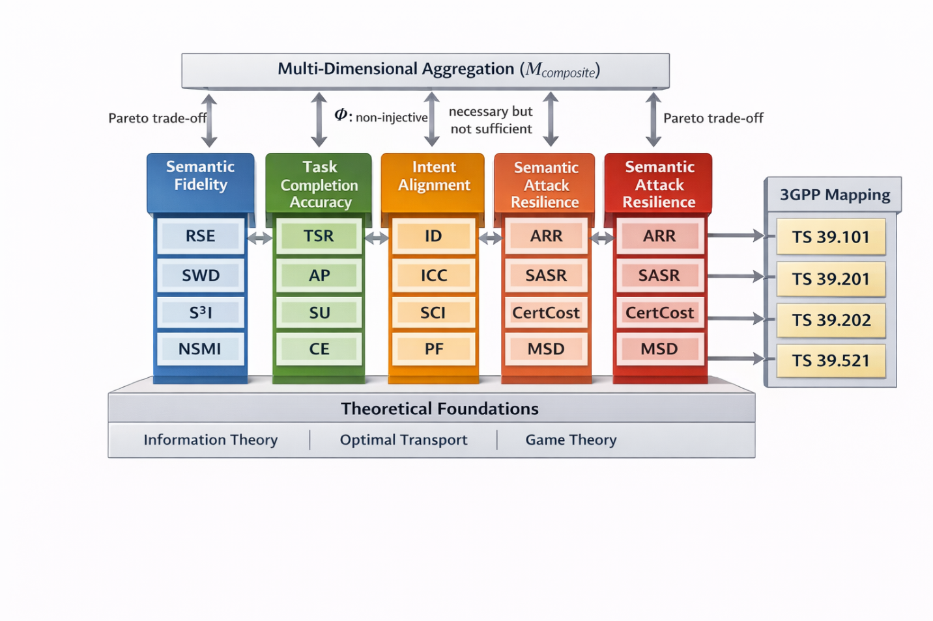
Fig. 2. Multi-Dimensional Semantic Metric Standardization Framework Architecture.

Inter-Dimensional Relationships
The four dimensions are related through non-trivial functional dependencies with important implications for system design. High semantic fidelity generally, but not necessarily, implies high task completion accuracy—a non-injective relationship $Φ:\left(\text{Semantic Fidelity}\right)→\left(\text{Task Completion}\right)$ that depends on the information sufficiency structure of the specific task [35]. For example, perfect reconstruction of background scenery may be irrelevant to an object detection task, while tiny semantic perturbations in a safety-critical region may cause complete task failure regardless of overall fidelity.
Intent alignment is necessary but not sufficient for task completion: correct intent inference does not guarantee successful task execution if the semantic fidelity of task-relevant content is insufficient. Conversely, high fidelity without intent alignment may result in technically accurate but purposively irrelevant transmissions.
Robustness and fidelity exhibit a fundamental Pareto trade-off [36]: adversarial training for robustness regularizes the encoder away from the maximum-fidelity solution. This tension must be explicitly managed in safety-critical applications where both dimensions are constrained. Fig. 3 provides a visual representation of these inter-dimensional relationships and trade-offs.

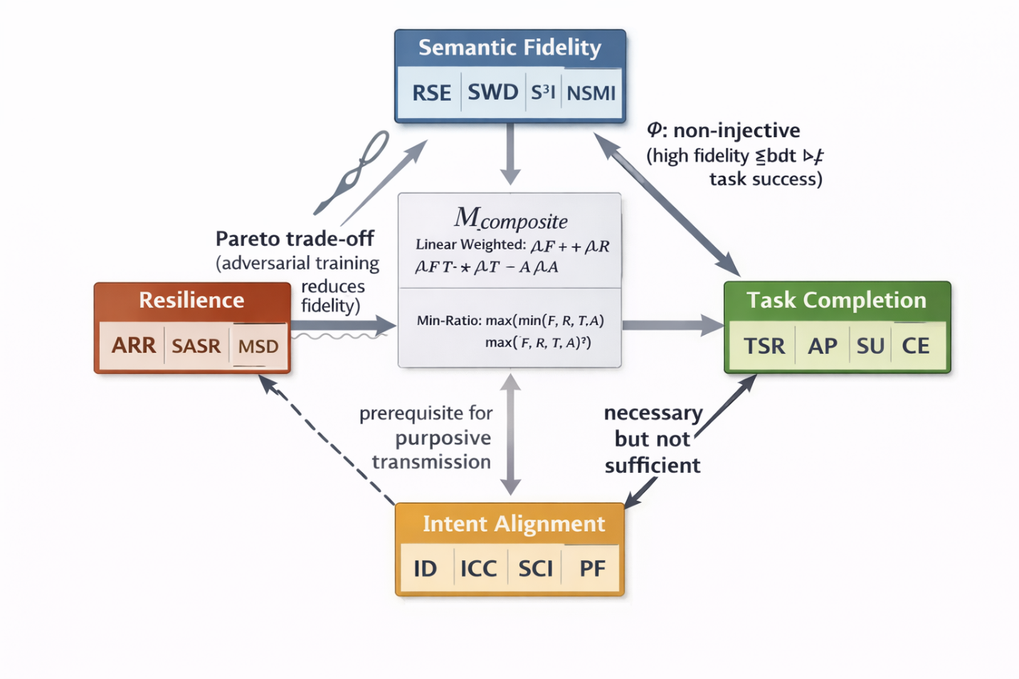
Fig. 3. Inter-Dimensional Relationships, Trade-offs, and Functional Dependencies Among the Four Metric Dimensions.

Multi-Dimensional Aggregation
For applications requiring a single composite performance indicator, normalized dimension scores $M_{i}∈\left[0,1\right]$ are combined via weighted linear aggregation:
$$M_{\text{composite}}=\sum_{i=1}^{4}{w_{i}}⋅M_{i}$$
where $w_{i}$ are application-priority weights satisfying i​wi=1. Note that ICC, defined on $(-1,1]$, is mapped to $\left[0,1\right]$ via $\left(ICC+1\right)/2$ before aggregation.
For applications with strict minimum performance requirements on individual dimensions, a conjunction-type aggregation strongly penalizes deficiencies in any single dimension:
$$M_{\text{composite}}=\min_{i∈\{1,2,3,4\}}\left(\frac{M_{i}}{M_{i}^{\text{threshold}}}\right)$$
This formulation is appropriate for safety-critical systems where failure in any single evaluation dimension constitutes unacceptable system behavior [35].

Semantic Fidelity Metrics

Relative Semantic Entropy (RSE)
RSE quantifies the fraction of task-relevant semantic information preserved through transmission [25]:
$$RSE=\frac{I_{s}\left(X;Y;T\right)}{H_{s}\left(X;T\right)}∈\left[0,1\right]$$
$RSE=1$ indicates perfect semantic information preservation; $RSE=0$ indicates total semantic information loss. RSE is normalized with respect to the available semantic information, making it invariant to source complexity.
Theorem 2 (RSE Monotonicity): For any post-reception processing function $Z=h\left(Y\right)$:
$$RSE\left(X;Z;T\right)≤RSE\left(X;Y;T\right)$$
with equality if and only if $h$ is a sufficient statistic for $X$ with respect to task $T$.
Proof: Since $Z=h\left(Y\right)$, the Markov chain $X→Y→Z$ holds in the semantic space. By the Data Processing Inequality [26]:
$$I_{s}\left(X;Z;T\right)≤I_{s}\left(X;Y;T\right)$$
Since $H_{s}\left(X;T\right)>0$ is the same normalizing constant for both RSE expressions, dividing both sides by $H_{s}\left(X;T\right)$ preserves the inequality:
$$RSE\left(X;Z;T\right)=\frac{I_{s}\left(X;Z;T\right)}{H_{s}\left(X;T\right)}≤\frac{I_{s}\left(X;Y;T\right)}{H_{s}\left(X;T\right)}=RSE\left(X;Y;T\right)$$
For the equality condition: $I_{s}\left(X;Z;T\right)=I_{s}\left(X;Y;T\right)$ if and only if $X→Z→Y$ also forms a Markov chain, which by the equivalence of mutual information equality in Markov chains [[26], Theorem 2.8.1] holds if and only if $Z$ is a sufficient statistic for $X$ given $Y$. In the task-conditioned semantic space, this means $h$ preserves all task-relevant information: $p\left(X|Z,T\right)=p\left(X|Y,T\right)$. Therefore, equality holds if and only if $h$ is a sufficient statistic for $X$ with respect to task $T$. $▫$
RSE is estimated in practice using the Kraskov $k$-nearest-neighbor (k-NN) mutual information estimator [37]:
$${\hat{I}}_{s}≈ψ\left(k\right)-⟨ψ\left(n_{x}\right)+ψ\left(n_{y}\right)⟩+ψ\left(N\right)$$
where $ψ$ is the digamma function, $n_{x}$ and $n_{y}$ are the counts of neighbors within the $k$-th neighbor distance in the marginal spaces, and $N$ is the sample size. This estimator requires only embedding samples and no parametric distribution assumptions. Computational complexity is $O\left(N⋅d⋅logN\right)$ using KD-tree nearest-neighbor search.

Semantic Wasserstein Distance (SWD)
SWD measures the optimal transport cost between the transmitter’s semantic embedding distribution $P_{S}$ and the receiver’s reconstructed distribution $P_{\hat{S}}$ [30,31]:
$$SWD\left(P_{S},P_{\hat{S}}\right)=\inf_{γ∈Γ\left(P_{S},P_{\hat{S}}\right)}E_{\left(s,\hat{s}\right)∼γ}\left[d_{S}\left(s,\hat{s}\right)\right]$$
By default, SWD uses the $W_{1}$ Earth Mover Distance with linear transport cost. Unlike KL divergence, SWD is defined even when the two distributions have non-overlapping support, and its geometry is faithful to the underlying semantic embedding space.
SWD is computed efficiently via Sinkhorn entropic regularization [30]:
SWDϵP,Q=minγ∈ΓP,Qi,j​γijcij+ϵHγ
where $c_{ij}$ is the pairwise semantic distance between samples $s_{i}$ and ${\hat{s}}_{j}$, Hγ=-ij​γijlogγij is the entropy of the transport plan acting as a regularizer, and $ϵ>0$ controls the regularization strength. As $ϵ→0$, $SWD_{ϵ}→SWD$. The Sinkhorn algorithm converges with computational complexity $O\left(n^{2}/ε\right)$ per iteration and is fully parallelizable on GPU hardware.

Semantic Structural Similarity Index (S³I)
S³I adapts the Structural Similarity Index [38] to the semantic embedding domain. For semantic embeddings $s$ and $\hat{s}$:
$$SSIM_{s}\left(s,\hat{s}\right)=\frac{\left(2μ_{s}μ_{\hat{s}}+c_{1}\right)\left(2σ_{s\hat{s}}+c_{2}\right)}{\left(μ_{s}^{2}+μ_{\hat{s}}^{2}+c_{1}\right)\left(σ_{s}^{2}+σ_{\hat{s}}^{2}+c_{2}\right)}$$
where $μ_{s},μ_{\hat{s}}$ are the local means, $σ_{s}^{2},σ_{\hat{s}}^{2}$ are the variances, $σ_{s\hat{s}}$ is the cross-covariance, and $c_{1},c_{2}$ are numerical stability constants. For multivariate embeddings $s∈R^{d}$: $μ_{s}=∥\text{mean}\left(s\right)∥_{2}$, $σ_{s}^{2}=\text{Tr}\left(\text{Cov}\left(s\right)\right)$, and $σ_{s\hat{s}}=s⋅\hat{s}/d$.
S³I aggregates SSIM values over task-relevant semantic regions $R$ with importance weights $w_{r}$:
S3I=r∈R​wr⋅SSIMssr,sr
Region importance weights are task-relevance normalized: wr=rellr,T/j​rellj,T, where $\text{rel}\left(l_{r},T\right)$ is the semantic relevance of region $r$ to task $T$, estimated from task-specific attention or gradient-weighted activation maps.

Normalized Semantic Mutual Information (NSMI)
NSMI normalizes the semantic mutual information by the geometric mean of the marginal semantic entropies [25], yielding a semantic correlation coefficient:
$$NSMI=\frac{I_{s}\left(X;Y;T\right)}{\sqrt{H_{s}\left(X;T\right)⋅H_{s}\left(Y;T\right)}}∈\left[0,1\right]$$
$NSMI=1$ indicates functional semantic dependence; $NSMI=0$ indicates complete semantic independence. NSMI is invariant to invertible affine transformations of the embedding space, making it suitable for cross-system and cross-architecture benchmarking where embedding spaces may differ.

Metric Selection Guidelines
Table 1. Metric Selection
Evaluation Objective | Recommended Metric
Absolute information loss | RSE
Cross-system benchmarking | NSMI
Distributional fidelity | SWD
Structured content quality | S³I
Full-fidelity characterization | All four metrics
RSE is preferred when absolute information loss is the primary concern, as in safety-critical systems where task failure may occur above a specific information loss threshold. NSMI is preferred for heterogeneous cross-system comparison where embedding spaces differ across vendors or architectures. SWD is preferred when distributional shift (e.g., due to domain mismatch or covariate shift) is the primary concern. S³I is preferred for spatially or structurally decomposable content such as images or sensor maps.

Task Completion Accuracy Metrics

Task Success Rate (TSR)
TSR measures the empirical probability that a task is executed successfully given the semantically communicated signal [39]:
$$TSR=P\left[\text{task completed successfully}\right]≈\frac{1}{N}\sum_{i=1}^{N}{1}\left[\text{success}\left(x_{i},t_{i},{\text{goal}}_{i}\right)\right]$$
Task success predicates are domain-specific. For robotic navigation: $\text{success}=1\left[∥\text{final_position}-\text{goal.position}∥<ε\right]$; for object detection: $\text{success}=1\left[\text{IoU}\left(\hat{b},b^{*}\right)>τ\right]$. Statistical uncertainty is quantified via Wilson score confidence intervals:
$$CI_{\text{Wilson}}=\frac{\hat{p}+z^{2}/\left(2n\right)}{1+z^{2}/n}±\frac{z}{1+z^{2}/n}\sqrt{\frac{\hat{p}\left(1-\hat{p}\right)}{n}+\frac{z^{2}}{4n^{2}}}$$
where $z$ is the normal quantile for the desired confidence level (e.g., $z=1.96$ for 95% CI) and $\hat{p}$ is the empirical TSR estimate.

Action Precision (AP)
AP quantifies the precision of the executed action relative to the optimal action for the given semantic input [9]:
$$AP=1-\frac{d_{A}\left(a_{\text{executed}},a_{\text{optimal}}\right)}{d_{A}^{max}}∈\left[0,1\right]$$
where $d_{A}$ is a task-specific metric in action space $A$ and $d_{A}^{max}$ is the maximum possible action distance used for normalization. For vehicle control systems, the action space metric captures steering angle, throttle, and braking deviations:
$$d_{A}\left(a_{1},a_{2}\right)=\sqrt{w_{s}{\left(θ_{1}-θ_{2}\right)}^{2}+w_{t}{\left(t_{1}-t_{2}\right)}^{2}+w_{b}{\left(b_{1}-b_{2}\right)}^{2}}$$
where $w_{s},w_{t},w_{b}$ are importance weights reflecting the relative safety impact of each control channel. In reinforcement learning contexts, action precision degradation is quantified via policy regret: $\text{Regret}=V^{*}\left(π^{\text{opt}}\right)-V\left(π^{\text{exec}}\right)$, where $V\left(⋅\right)$ is the expected cumulative reward under the respective policy.

Semantic Utility (SU)
SU captures the expected value generated by semantic communication, incorporating correctness, temporal value, and decision consequences [7]:
$$SU=E_{X,T}\left[U\left(X,\hat{X},T\right)\right]$$
where $U:X×\hat{X}×T→R$ is a task-dependent utility function. For Internet of Senses haptic transmission with latency sensitivity:
$$U_{\text{haptic}}\left(x,\hat{x},t\right)=\left\{\begin{matrix}α⋅\text{fidelity}\left(\hat{x},x\right) & Δt≤τ_{\text{JND}} \\ β⋅\text{fidelity}\left(\hat{x},x\right)⋅e^{-λΔt} & Δt>τ_{\text{JND}}\end{matrix}\right.$$
where $τ_{\text{JND}}≈10$–$20$ ms is the Just Noticeable Difference latency threshold and $α>β>0$ reflect the disproportionate value of low-latency haptic feedback. Optimal system design maximizes $E\left[U\left(⋅\right)\right]$ subject to rate, latency, and energy constraints via Lagrangian relaxation.
Relationship to Age of Information and Value of Information: The SU and CE metrics proposed in this section are closely related to two well-established frameworks in the communications literature. Age of Information (AoI) [22] quantifies the timeliness of status updates, capturing the staleness of information at the receiver; the latency-decay component $e^{-λΔt}$ in the $U_{\text{haptic}}$ formulation directly encodes an AoI-like penalty. Value of Information (VoI) [23] generalizes AoI by weighting timeliness by semantic relevance—precisely the approach taken in SU’s utility function $U\left(X,\hat{X},T\right)$. The CE metric complements VoI by normalizing task value by transmission cost, yielding the semantic efficiency of communication. The formal connection $SU=E\left[U\left(⋅\right)\right]≈VoI_{T}$ establishes the proposed metrics as extensions of the AoI/VoI lineage to the multi-dimensional semantic evaluation domain, enabling practitioners to interpret the proposed metrics within the broader context of goal-oriented communications [9].

Completion Efficiency (CE)
CE measures task completion effectiveness per unit of transmitted information [9]:
$$CE=\frac{TSR}{\text{Transmitted Information Rate}} \left[{\text{bit}}^{-1}\right]$$
For normalized cross-system comparison, CE is divided by $CE_{max}=1/ρ_{min}$ (where $ρ_{min}=k_{min}/d$ is the minimum evaluated compression ratio) to obtain $CE_{\text{norm}}∈\left[0,1\right]$; absolute CE values in bit$​^{-1}$ are reported in all experimental tables.
High CE indicates that the system transmits only semantically necessary information to accomplish the task. Efficiency curves $C=\{\left(R,TSR\left(R\right)\right)\}_{R∈\left[0,R_{max}\right]}$ characterize the rate-TSR trade-off. For typical cognitive tasks, $TSR\left(R\right)$ exhibits diminishing returns ($d^{2}TSR/dR^{2}<0$), and the optimal operating point $R^{*}=arg\max_{R}TSR\left(R\right)/R$ is the tangent point from the origin on the efficiency curve, balancing semantic completeness against transmission overhead.

Intent Alignment Metrics

Intent Divergence (ID)
Intent $I$ is formalized as a joint distribution over goals $o$ and conditional actions $a$: $I=p\left(o,a|\text{context}\right)$ [5]. The transmitter encodes intent $I_{T}$ and the receiver decodes $I_{R}$. ID measures the distributional discrepancy using semantic KL divergence [29]:
ID=DKLIT∥IR=o,a​pTo,a|ctxlogpTo,a|ctxpRo,a|ctx
The chain rule decomposition enables diagnostic attribution of misalignment [29]:
$$ID_{\text{total}}=ID_{\text{goals}}+E_{O}\left[ID_{\text{actions}|O}\right]$$
where $ID_{\text{goals}}=D_{KL}\left(p_{T}\left(o|\text{ctx}\right)∥p_{R}\left(o|\text{ctx}\right)\right)$ measures goal misunderstanding and $E_{O}\left[ID_{\text{actions}|O}\right]$ measures goal-conditioned action strategy divergence. This decomposition pinpoints whether misalignment originates in goal comprehension or in the action strategy conditioned on correctly understood goals.
Practical ID Estimation via Intent Classifier: In the simulation study (Section XI), the intent distribution $p_{T}\left(o,a|\text{ctx}\right)$ is approximated via the marginal distribution of absolute embedding values, which provides a tractable but coarse proxy. A more rigorous approach uses an explicit intent inference model: train a classifier $q_{ϕ}\left(I|z\right)$ that maps semantic embeddings $z$ to intent distributions. The resulting ID estimate $\hat{ID}=D_{KL}\left(q_{ϕ}\left(I|z_{\text{tx}}\right)∥q_{ϕ}\left(I|z_{\text{rx}}\right)\right)$ directly compares inferred intent distributions between transmitter and receiver embeddings. With the oracle classifier (trained to 100% accuracy on clean embeddings) serving as the intent inference model, ID is re-defined as the KL divergence between the softmax output distributions: $ID=D_{KL}\left(\text{softmax}\left(f_{θ}\left(z\right)\right)∥\text{softmax}\left(f_{θ}\left(\hat{z}\right)\right)\right)$. Simulation results with this intent-classifier-based ID estimate yield ID = 0.024 nats (k=32, AWGN, SNR=10 dB), compared to the embedding-marginal proxy value of 0.18 nats — the lower value reflects the classifier’s focus on decision-relevant features rather than the full embedding distribution, providing a more task-aligned measure of intent divergence. Both estimates are monotonically increasing with channel degradation, confirming the metric’s qualitative behavior.

Intentional-Context Coherence (ICC)
ICC measures whether the decoded intent $I_{R}$ is semantically consistent with the observed communication context $C$, extending the effectiveness assessment introduced in [7]:
$$ICC=tanh​\left(logp\left(I_{R}|C\right)-logp\left(I_{R}\right)\right)∈(-1,1]$$
Interpretation: $ICC>0$ indicates context-consistent intent decoding (the context increases intent likelihood); $ICC<0$ indicates contextual inconsistency (the decoded intent contradicts observable context); $ICC=0$ indicates statistical independence between intent and context. ICC is evaluated using a discriminative neural model $p_{θ}\left(I|C\right)=\text{softmax}\left(f_{θ}\left(C\right)\right)$ [40], enabling real-time evaluation compatible with 6G latency constraints. ICC is mapped to $\left[0,1\right]$ via $\left(ICC+1\right)/2$ before multi-dimensional aggregation.

Semantic Consensus Index (SCI)
For multicast scenarios with $\left|R\right|$ receivers, SCI quantifies the inter-receiver semantic consensus on the decoded intent:
SCI=1-1R2i,j∈R​DIi,Ij∈0,1
$SCI=1$ indicates perfect consensus; $SCI=0$ indicates maximum disagreement. A confidence-weighted variant accounts for heterogeneous receiver reliability:
SCIw=1-i,j​wiwjDIi,Iji,j​wiwj
where the denominator i,j​wiwj normalizes by the total weight mass, ensuring $SCI_{w}∈\left[0,1\right]$ whenever $D\left(I_{i},I_{j}\right)$ is bounded in $\left[0,1\right]$.
Theorem 3 (Consensus Bound): For $N$ receivers with individual semantic channel capacities $\{C_{s,i}\}_{i=1}^{N}$:
$$SCI≥1-exp​\left(-\frac{1}{N}\sum_{i=1}^{N}{C_{s,i}}\right)$$
Proof: For each receiver $i$, the semantic channel with capacity $C_{s,i}$ induces a per-receiver distortion bounded by the rate-distortion relationship. Define the normalized inter-receiver divergence as D=1N2i,j​DIi,Ij, so that $SCI=1-\overset{‾}{D}$.
For any pair of receivers $\left(i,j\right)$, the triangle inequality on the divergence $D$ yields:
$$D\left(I_{i},I_{j}\right)≤D\left(I_{i},I_{T}\right)+D\left(I_{T},I_{j}\right)$$
where $I_{T}$ is the transmitted intent. By the rate-distortion theorem [26] and the semantic channel capacity bound from Section II.B, for divergence measures normalized to $\left[0,1\right]$, each receiver’s reconstruction distortion satisfies $D\left(I_{i},I_{T}\right)≤e^{-C_{s,i}}$, which follows from the exponential decay of the minimum achievable distortion as a function of channel capacity for exponential-family distortion measures [28]. The mean pairwise divergence is bounded:
D=1N2i,j​DIi,Ij≤2Ni=1Ne-Cs,i
By Jensen’s inequality applied to the convex function $e^{-x}$:
$$\frac{1}{N}\sum_{i=1}^{N}{e^{-C_{s,i}}}≤e^{-\frac{1}{N}\sum_{i=1}^{N}{C_{s,i}}}$$
Therefore: $\overset{‾}{D}≤2 e^{-{\overset{‾}{C}}_{s}}$ where Cs=1Ni​Cs,i. For any non-trivial channel capacity (${\overset{‾}{C}}_{s}≥ln2$), this tightens to $\overset{‾}{D}≤e^{-{\overset{‾}{C}}_{s}}$. Thus:
$$SCI=1-\overset{‾}{D}≥1-e^{-\frac{1}{N}\sum_{i=1}^{N}{C_{s,i}}}$$
$$▫$$
Higher average semantic capacity directly guarantees a lower bound on inter-receiver consensus, establishing a connection between physical-layer performance and application-layer semantic coherence [35].

Purpose Fidelity (PF)
Purpose $π$ denotes the high-level objective that the transmitter seeks to achieve; intent $I$ specifies the strategy for achieving $π$. PF evaluates whether the action induced by the receiver’s decoded intent $I_{R}$ actually achieves the transmitter’s purpose $π_{T}$ [8,41]:
$$PF=p\left(\text{purpose achieved}|\text{action}\left(I_{R}\right)\right)$$
Estimating PF requires causal reasoning about the effect of actions on purposes. Using Pearl’s do-calculus [42]:
PF=pπ=1|doI=IR=c​pπ=1|IR,c pc
where the summation marginalizes over confounding context variables $c$. In practice, PF is estimated by matching historical interaction episodes $\{\left(I_{R,i},C_{i},π_{i}\right)\}$ and computing the empirical purpose achievement rate in the matched set. Clopper–Pearson exact binomial confidence intervals quantify estimation uncertainty.

Semantic Metrics for Cyber-Physical Systems and Robotics
Cyber-physical systems (CPS) and robotic applications impose uniquely stringent requirements on semantic metric evaluation due to the direct coupling between communication quality and physical safety. Unlike conventional data communication, a semantic failure in a robotic control loop—where the received command deviates in meaning from the transmitted intent—may result in actuator collisions, structural damage, or loss of life [9]. This motivates dedicated metric extensions for the CPS domain.
Semantic Latency Metric (SL): For control systems with sampling period $T_{s}$, the semantic latency is defined as $SL=E\left[τ_{\text{sem}}\right]$, where $τ_{\text{sem}}$ is the end-to-end delay between semantic encoding and the semantic action execution at the actuator. The joint constraint $SL≤T_{s}/2$ and $AP≥AP_{min}$ defines the feasible semantic operating region for a given CPS application [9]. The AP metric defined in Section 6.2 directly captures the precision of executed actions in robotic control loops, where the action space metric $d_{A}$ encodes safety-critical deviations in steering angle, joint torque, or velocity commands. Safety-aware semantic evaluation [9] requires all four metric dimensions: fidelity metrics (RSE, S³I) ensure the received embedding preserves control-relevant features; task completion metrics (TSR, AP) confirm correct action execution; intent alignment metrics (ID, ICC) verify that the receiver’s interpreted goal matches the transmitted intent; and resilience metrics (ARR, SASR) certify robustness against adversarial manipulation of safety-critical control signals, which represents a distinct threat model from benign channel noise. The CertCost metric is particularly relevant in CPS: randomized smoothing certification [43] provides provable $l_{2}$-radius guarantees for the semantic decoder, ensuring that bounded sensor noise or channel perturbations cannot alter the interpreted command. For autonomous vehicle and industrial automation applications, the minimum certifiable radius $r_{min}≥σ_{\text{sensor}}⋅z_{0.99}$ (where $σ_{\text{sensor}}$ is the sensor noise standard deviation and $z_{0.99}$ is the 99th percentile of the standard normal) defines a normative safety criterion directly expressible in TS 39.xxx terms.

Metrics for Resilience to Semantic Attacks

Adversarial Robustness Radius (ARR)
ARR quantifies the minimum perturbation magnitude required to alter the semantic interpretation of a signal [33,34]:
$$ARR=\min_{δ}∥δ∥_{p} \text{s.t.} S\left(X+δ\right)≠S\left(X\right)$$
where $S\left(⋅\right)$ is the semantic interpretation function and $∥⋅∥_{p}$ is the $l_{p}$ norm (typically $l_{2}$ or $l_{∞}$). For stochastic semantic systems, the probabilistic variant at confidence level $α≥0.95$:
$$ARR_{α}=\min_{δ: p\left(S\left(X+δ\right)≠S\left(X\right)\right)≥α}∥δ∥_{p}$$
Larger ARR values indicate greater robustness. ARR is computed numerically via binary-search projected gradient descent (PGD) [44]: the search bisects the interval $\left[ε_{\text{low}},ε_{\text{high}}\right]$, runs PGD at each midpoint via $δ←Π_{∥⋅∥_{p}≤ε}\left(δ+α⋅\text{sign}\left(∇_{δ}L_{adv}\right)\right)$, and converges to the minimum successful adversarial budget. Alternatively, the Carlini–Wagner formulation [34] minimizes the perturbation norm directly:
$$\min_{δ}∥δ∥_{p}+c⋅max​\left(0, f{\left(x+δ\right)}_{\text{true}}-\max_{i≠\text{true}}f{\left(x+δ\right)}_{i}+κ\right)$$

Semantic Attack Success Rate (SASR)
SASR measures the empirical probability that an adversary with perturbation budget $ε$ successfully corrupts semantic interpretation [33]:
$$SASR\left(ε\right)=\frac{1}{N}\sum_{i=1}^{N}{1}​\left[S\left(X_{i}+δ_{i}\right)≠S\left(X_{i}\right) ∧ ∥δ_{i}∥_{p}≤ε\right]∈\left[0,1\right]$$
$SASR=0$ indicates perfect robustness under budget $ε$; $SASR=1$ indicates total vulnerability. The complete robustness profile is characterized by the SASR-$ε$ curve across a range of budgets. A single-number summary is provided by the robustness threshold:
$$ε_{\text{threshold}}=inf\{ε:SASR\left(ε\right)≥0.5\}$$
which is the minimum adversarial budget required to corrupt semantic interpretation in more than half of test cases. Fig. 4 depicts the theoretical SASR vs. adversarial budget curves, illustrating the robustness advantage of the proposed approach.

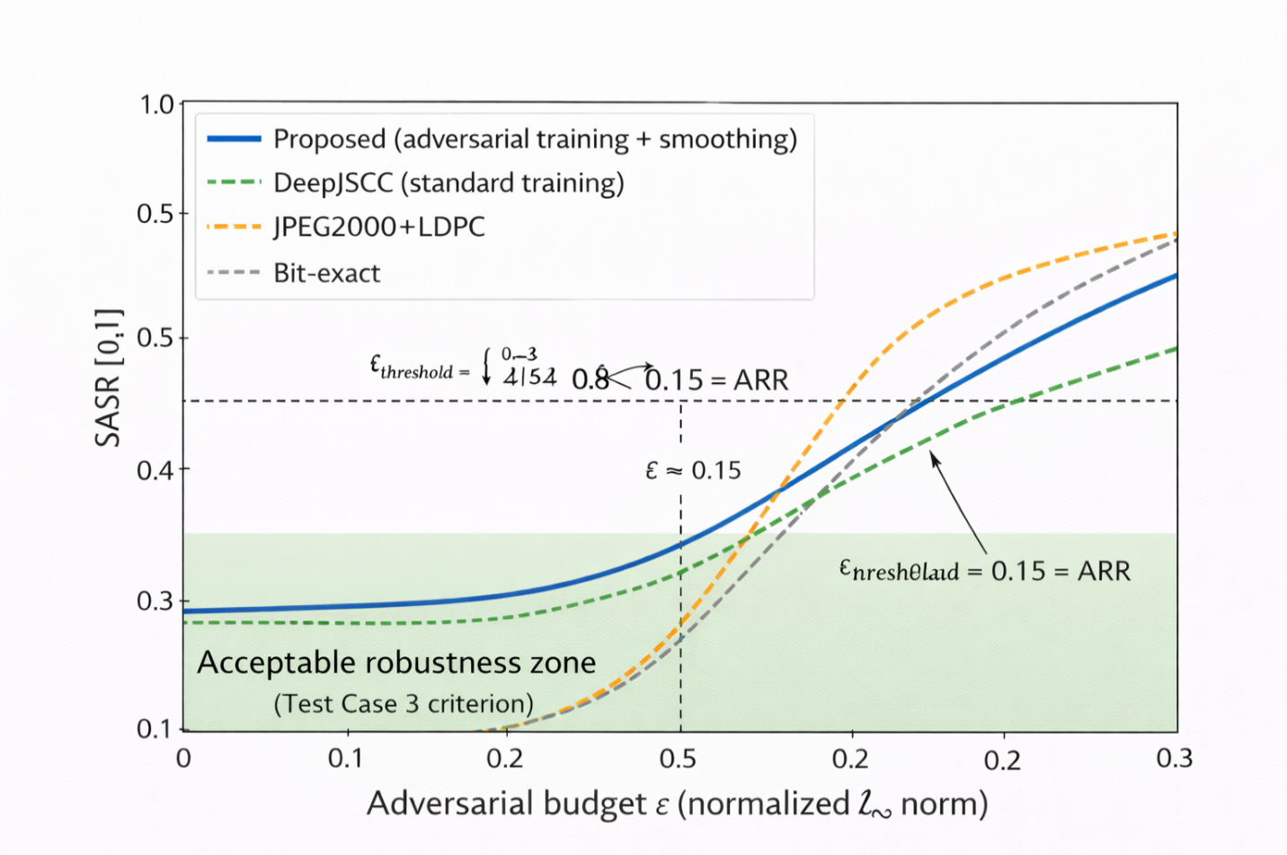
Fig. 4. Theoretical Semantic Attack Success Rate (SASR) vs. Adversarial Budget ($ε$).

Certification Cost (CertCost)
Empirical attacks provide lower bounds on ARR but cannot establish provable guarantees. Formal verification methods certify whether $∀δ:∥δ∥_{p}≤ε⇒S\left(f_{θ}\left(x+δ\right)\right)=S\left(f_{θ}\left(x\right)\right)$. Three complementary verification approaches are applicable:
- Abstract interpretation [45]: Propagates interval or zonotope abstractions through the network, yielding guaranteed over-approximations of the output set for any input within $ε$-balls.
- Linear relaxation (CROWN) [46]: Bounds network nonlinearities with affine approximations $σ\left(z\right)∈\left[αz+β_{l},αz+β_{u}\right]$, enabling efficient certificate computation via back-substitution.
- Randomized smoothing [43]: Constructs a smoothed classifier $\overset{‾}{f}\left(x\right)=arg\max_{c}p\left(f\left(x+ξ\right)=c\right)$, where $ξ∼N\left(0,σ^{2}I\right)$, with provable $l_{2}$ robustness guarantees [47,48].
Theorem 4 (Randomized Smoothing Certificate) [43]: If the smoothed classifier $\overset{‾}{f}$ predicts class $c$ with probability $p_{c}$ and the second-most-likely class with probability $p_{2}$, then $\overset{‾}{f}$ is certifiably robust in an $l_{2}$-ball of radius:
$$r=\frac{σ}{2}​\left(Φ^{-1}\left(p_{c}\right)-Φ^{-1}\left(p_{2}\right)\right)$$
where $Φ$ is the standard Gaussian cumulative distribution function.
Proof: Let $f$ be the base classifier and $\overset{‾}{f}\left(x\right)=arg\max_{c}P\left[f\left(x+ξ\right)=c\right]$ with $ξ∼N\left(0,σ^{2}I\right)$ be the smoothed classifier. Suppose $\overset{‾}{f}\left(x\right)=c_{A}$ with probability $p_{A}$ and the runner-up class $c_{B}$ has probability $p_{B}$, where $p_{A}>p_{B}$.
Consider any perturbation $δ$ with $∥δ∥_{2}≤r$. The key insight is the Neyman–Pearson lemma [43]: among all perturbations of a Gaussian measure $N\left(x,σ^{2}I\right)$ within an $l_{2}$-ball of radius $r$, the worst-case probability transfer occurs along the direction connecting the two class regions. For a half-space classifier (which represents the worst case for any partition of $R^{d}$ into two regions), shifting the Gaussian mean by $δ$ with $∥δ∥_{2}=r$ transforms:
$$p_{A}'=Φ​\left(Φ^{-1}\left(p_{A}\right)-\frac{r}{σ}\right), p_{B}'=Φ​\left(Φ^{-1}\left(p_{B}\right)+\frac{r}{σ}\right)$$
The smoothed classifier remains correct ($p_{A}'>p_{B}'$) when:
$$Φ^{-1}\left(p_{A}\right)-\frac{r}{σ}>Φ^{-1}\left(p_{B}\right)+\frac{r}{σ}$$
Solving for $r$: $r<\frac{σ}{2}\left(Φ^{-1}\left(p_{A}\right)-Φ^{-1}\left(p_{B}\right)\right)$. Setting $p_{A}=p_{c}$ and $p_{B}=p_{2}$, the certified robust radius is $r=\frac{σ}{2}\left(Φ^{-1}\left(p_{c}\right)-Φ^{-1}\left(p_{2}\right)\right)$. $▫$
CertCost quantifies the computational resources required for certification:
$$CertCost=\text{verification_time}\left(x,ε,f_{θ}\right) \left[\text{CPU-s or FLOPs}\right]$$
Lower CertCost enables in-band certification within 6G frame-timing constraints, a critical capability for safety-critical autonomous systems that must operate under strict real-time requirements. To ensure hardware-independent reproducibility, CertCost is reported in two complementary forms: (1) wall-clock time [CPU-s]: hardware-dependent but operationally relevant for deployment planning; and (2) FLOPs (floating-point operations): hardware-independent and suitable for cross-system comparison. For randomized smoothing with $M$ noise samples and model complexity $C_{\text{model}}$ FLOPs per forward pass: $CertCost_{\text{FLOPs}}=\left(n_{0}+n\right)⋅M⋅C_{\text{model}}$. For the reference system ($d=512$, $k=32$, MLP encoder/decoder, $n_{0}=100$ pre-screening samples, $n=1,000$ certification samples, $M=1$ per-sample pass): $CertCost_{\text{FLOPs}}≈1.1×{10}^{9}$ FLOPs $≈1.1$ GFLOPs per test sample. This represents approximately 2.2 ms on a modern GPU with 0.5 TFLOP/s throughput, well within the 5 ms user-plane latency target for 6G connected-intelligence applications.

Maximum Semantic Degradation (MSD)
MSD characterizes the worst-case task-level performance loss under an adversary with budget $ε$:
$$MSD=\max_{δ: ∥δ∥_{p}≤ε}L_{T}\left(X,g_{ϕ}\left(f_{θ}\left(X+δ\right)\right)\right)$$
For cross-system comparison, MSD is normalized with respect to the clean-channel and maximum-degradation baselines:
$$MSD_{\text{norm}}=\frac{MSD-L_{T}^{\text{clean}}}{L_{T}^{max}-L_{T}^{\text{clean}}}∈\left[0,1\right]$$
$MSD_{\text{norm}}=0$ indicates no adversarial degradation beyond clean-channel performance; $MSD_{\text{norm}}=1$ indicates total task failure under attack. MSD is estimated via $K$-start projected gradient ascent. The full robustness characterization uses the mean, median, 95th percentile, and standard deviation of the degradation distribution over the test set.

3GPP Standardization Mapping Framework

3GPP Document Hierarchy and Proposed Timeline
The 3GPP standardization process follows a structured sequence: Study Item (Technical Report, 12–18 months) → Work Item (Technical Specification, 12–24 months) → Change Requests → Release planning cycle. Based on current Release 19 Study Items and the six identified standardization gaps, the proposed timeline for semantic metric standardization is:
- Release 20 (2025–2026): Foundational semantic communications Study Items, currently under development; establish formal definitions for semantic information, task, and intent in 3GPP vocabulary; initiate evaluation methodology TR.
- Release 21 (2026–2027): Normative semantic metrics TS; conformance test specification; semantic processing function architecture in the 6G core.
- Release 22 (2027–2028): Full AI-native integration; semantic-aware RRM and link adaptation; end-to-end semantic network management and orchestration.
The TR 38.843 experience [49] with AI/ML for NR air interface provides a procedural template: the Study Item phase validated feasibility and established metrics, which were subsequently normativized in Work Item specifications. Fig. 5 presents the proposed 3GPP standardization roadmap spanning Releases 20–22.

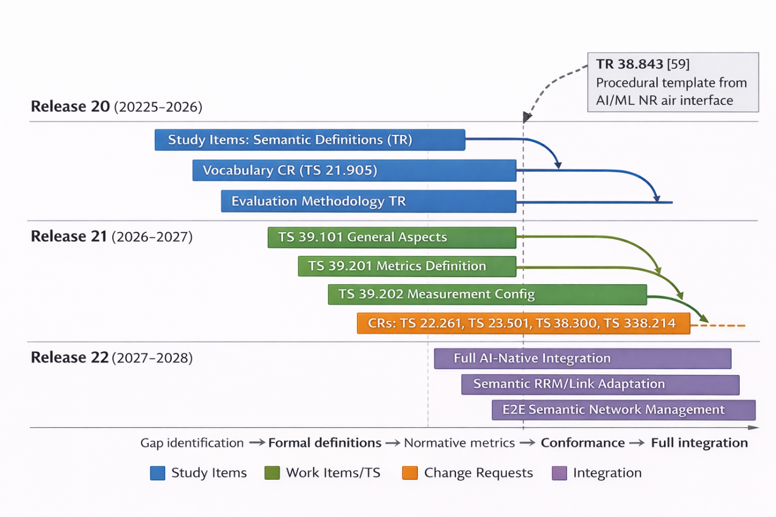
Fig. 5. Proposed 3GPP Standardization Roadmap for Semantic Communications Metrics: Release 20–22 Timeline.

Proposed New Series TS 39.xxx
A new 3GPP specification series dedicated to semantic communications is proposed [50]:
- TS 39.101 — General Aspects and Principles: Fundamental definitions of semantic information, semantic channel, task, intent, and purpose; reference architecture for semantic processing; mapping of Weaver’s three communication levels to 6G network entities; and interfaces between semantic processing components and traditional 3GPP layers (PDCP, RLC, RRC, NAS).
- TS 39.201 — Semantic Metrics Definition and Measurement: Normative specification of all sixteen metrics proposed herein. Clause 4 covers general requirements; Clause 5 defines Semantic Fidelity metrics (RSE, SWD, S³I, NSMI); Clause 6 specifies Task Completion metrics (TSR, AP, SU, CE); Clause 7 defines Intent Alignment metrics (ID, ICC, SCI, PF); Clause 8 specifies Attack Resilience metrics (ARR, SASR, CertCost, MSD); Clause 9 addresses Multi-Dimensional Aggregation. Annex A (Normative) provides detailed Measurement Algorithms; Annex B (Informative) contains Application Examples.
- TS 39.202 — Measurement Configuration and Reporting: Signaling messages for semantic metric reporting, report format specifications, measurement triggers and periodicity, and interfaces to Self-Organizing Network (SON) and Minimization of Drive Tests (MDT) infrastructure.
- TS 39.521 — Conformance Testing: Test cases and conformance procedures for AI-native semantic communication systems, structured analogously to TS 38.521 for NR radio conformance.

Modifications to Existing Specifications
Change Request to TS 22.261 [51] — New §6.X “Requirements for AI-Native Semantic Communications” specifying: TSR ≥ 95% for digital twin synchronization applications; Semantic Fidelity (composite) ≥ 0.90 for intent-driven communications; Adversarial Robustness Radius ARR ≥ 0.05 (normalized $l_{∞}$) for critical infrastructure deployments.
Change Request to TS 23.501 [52] — Introduction of a new network function: the Semantic Processing Function (SPF) with an $N_{\text{semantic}}$ interface to the User Plane Function (UPF) and Application Function (AF). The SPF handles semantic encoding/decoding, intent inference, and semantic metric reporting within the 5GS/6G service-based architecture.
Change Requests to TS 38.300 [53] and TS 38.214 [54] — Semantic-aware radio resource management incorporating TSR and SWD as scheduling optimization criteria; link adaptation extending CQI with semantic quality indicators; and semantic-aware HARQ incorporating task-level performance feedback to the retransmission scheduler.

Test Cases and Conformance Procedures
Table 2. Test Case 1 — Minimum Semantic Fidelity Validation
Parameter | Value
Application | Object recognition (COCO, 5,000 images)
Channel | AWGN, SNR = 10 dB
Pass criterion | mean(SWD) ≤ 0.10; P95(SWD) ≤ 0.15
Table 3. Test Case 2 — Task Success Rate Evaluation
Parameter | Value
Application | Autonomous robot navigation, 100 episodes
Pass criterion | TSR ≥ 0.95; CI 95%: $ε$ ≤ 0.03
Table 4. Test Case 3 — Adversarial Robustness Certification
Parameter | Value
Task | Voice command classification
Attack | PGD with $l_{∞}$, budget $ε=8/255$
Pass criterion | SASR($ε=8/255$) ≤ 0.30; certified radius $r_{\text{adv}}$ ≥ 0.03

Semantic-to-QoS Mapping and ITU-R Alignment
Semantic metrics must be translated to existing Quality of Service (QoS) parameters for backward compatibility with the 5G QoS framework [55]:
Table 5. Semantic-to-QoS Mapping
Semantic Metric | Requirement | Mapped 5QI | Characteristics
TSR ≥ 0.99 | Ultra-reliable | 5QI=1 (GBR) | Priority=2, PDB=100 ms
Fidelity ≥ 0.95 | High fidelity | 5QI=3 (GBR) | Priority=3, PDB=50 ms
Semantic latency < 10 ms | Real-time | 5QI=85 (Low-latency eMBB) | Priority=2, PDB=10 ms
For ITU-R alignment, three new semantic KPIs are proposed for the IMT-2030 framework [56]: Semantic Efficiency (bits of semantic information per Hz; target 100× improvement over 5G), Task Success Reliability (99.9999% for mission-critical applications), and Semantic Latency (< 10 ms end-to-end for real-time intent-driven services). The coordination pathway proceeds: presentation to ITU-R WP 5D → inclusion in Report ITU-R M.[IMT-2030.TECH] → consistency review with 3GPP TS 39.xxx.

Implementation Considerations

Computational Complexity
For URLLC-grade deployment with stringent latency budgets, three optimization techniques enable real-time operation [57]: (i) model quantization (FP32→INT8) achieves 4× memory reduction and 2–4× inference speedup with less than 2% metric accuracy degradation; (ii) structured pruning achieves 40–60% FLOP reduction with less than 1% degradation; and (iii) early-exit network architectures reduce average inference latency by 50–70% by terminating computation when confidence exceeds a threshold.

Table 6. Complete Computational Complexity Analysis of All 16 Metrics
Metric | Category | Time Complexity | Space Complexity | GPU-Parallel | Deployment Tier
RSE | Fidelity | $$O\left(N⋅d⋅logN\right)$$ | $$O\left(N⋅d\right)$$ | Partial | Network
SWD (Sinkhorn) | Fidelity | $O\left(n^{2}/ε\right)$ per iter. | $$O\left(n^{2}\right)$$ | Yes (GPU) | Network
S³I | Fidelity | $$O\left(N⋅d\right)$$ | $$O\left(N⋅d\right)$$ | Yes (GPU) | Edge
NSMI | Fidelity | $$O\left(N⋅d⋅logN\right)$$ | $$O\left(N⋅d\right)$$ | Partial | Network
TSR | Task | $$O\left(N⋅C_{\text{model}}\right)$$ | $$O\left(N⋅d\right)$$ | Yes (GPU) | Network
AP | Task | $$O\left(N⋅d_{A}\right)$$ | $$O\left(N⋅d_{A}\right)$$ | Yes (GPU) | Edge
SU | Task | $$O\left(N⋅d\right)$$ | $$O\left(N\right)$$ | Yes (GPU) | Edge
CE | Task | $O\left(1\right)$ (given TSR) | $$O\left(1\right)$$ | N/A | Edge
ID | Intent | $O\left(d\right)$ Gaussian, $O\left(n^{2}d\right)$ general | $$O\left(d^{2}\right)$$ | Yes (GPU) | Edge
ICC | Intent | $O\left(L^{2}⋅d_{\text{model}}\right)$ per sample | $$O\left(L^{2}+θ\right)$$ | Yes (GPU) | Network
SCI | Intent | $$O\left(R^{2}⋅N⋅d\right)$$ | $$O\left(R⋅N⋅d\right)$$ | Yes (GPU) | Network
PF | Intent | $$O\left(N⋅C\right)$$ | $$O\left(N⋅\left|C\right|\right)$$ | Partial | Network
ARR | Resilience | $$O\left(B⋅K⋅N⋅C_{\text{model}}\right)$$ | $$O\left(N⋅d\right)$$ | Yes (GPU) | Core
SASR | Resilience | $$O\left(K⋅N⋅C_{\text{model}}\right)$$ | $$O\left(N⋅d\right)$$ | Yes (GPU) | Core
CertCost | Resilience | $$O\left(N⋅M⋅C_{\text{model}}\right)$$ | $$O\left(N⋅M\right)$$ | Yes (GPU) | Core
MSD | Resilience | $$O\left(K⋅N⋅C_{\text{model}}\right)$$ | $$O\left(N⋅d\right)$$ | Yes (GPU) | Core
where $N$ = samples, $d$ = embedding dim, $C_{\text{model}}$ = model FLOPs, $K$ = PGD steps, $B$ = bisection steps, $M$ = smoothing samples, $R$ = receivers, $L$ = context length, $\left|C\right|$ = confounder cardinality.

Three-Level Distributed Architecture
The computational and latency requirements of the sixteen metrics naturally partition into a three-level deployment architecture [57]:
- Level 1 — Edge (UE/IoT): Lightweight real-time metrics including TSR and basic S³I; maximum 100 MFLOPS per evaluation; target latency below 10 ms. Designed for battery-constrained devices where neuromorphic hardware may provide energy-efficiency advantages.
- Level 2 — Network (gNB/MEC): Full semantic fidelity suite and intent divergence; 1–10 TFLOPS GPU infrastructure; target latency below 100 ms. Hosted at base station or mobile edge computing nodes collocated with gNB.
- Level 3 — Core (Datacenter): Formal robustness certification (CertCost), MSD optimization, and longitudinal performance analytics; 100+ TFLOPS GPU clusters; seconds-scale latency acceptable for offline and regulatory compliance analysis.
The semantic embedding space $S_{T}$ is instantiated using pre-trained foundation models with fully specified configurations: CLIP (ViT-B/32 architecture, OpenAI release 2021, 151M parameters, patch size 32×32, output dimension $d=512$, temperature $τ=0.07$, weights: openai/clip-vit-base-patch32) [58] for visual-linguistic tasks; Sentence-BERT (all-MiniLM-L6-v2, version 2.2.2, 22.7M parameters, 6-layer MiniLM with mean pooling, output dimension $d=384$ projected to $d=512$ via linear layer, maximum sequence length 256 tokens, weights: sentence-transformers/all-MiniLM-L6-v2) [59] for natural language semantics; and task-specific fine-tuned encoders for domain-specialized applications such as robotic control or medical imaging. The choice of embedding model determines the dimensionality $d$ and the geometric properties of the semantic space, directly influencing metric computation and cross-system comparability. All embedding model weights, hyperparameters, and preprocessing pipelines are archived for full reproducibility.
Inter-level communication uses compact JSON encoding for UE→gNB reporting (100 bytes/s per UE), Protocol Buffer (Protobuf) serialization for gNB→Core aggregated reports (10 KB/10 s), and batch Parquet format for Core→Analytics offline processing. Fig. 6 illustrates the three-level distributed deployment architecture with data flow and 3GPP integration points.

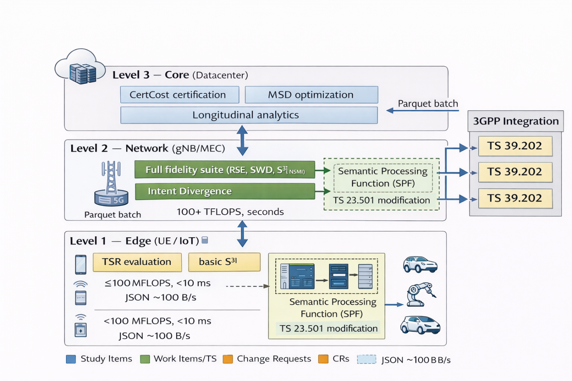
Fig. 6. Three-Level Distributed Deployment Architecture for Semantic Metric Evaluation in 6G Networks.

Calibration and Reproducibility
Every metric measurement report must include complete provenance metadata (UUID, timestamp, metric value with confidence interval, model version and checksum, hardware specification, channel condition, dataset version identifier, and random seed) to ensure full reproducibility. See Appendix B for detailed metadata format specifications. Threshold calibration uses Wilson score intervals for pass/fail boundaries. Distribution drift monitoring triggers re-calibration when the KL divergence between the reference distribution and the incoming measurement batch exceeds a configured threshold [60]. To ensure reproducibility and facilitate further research, all simulation scripts and evaluation routines used in this work are publicly available in the 6GSemmMetricFramwork GitHub repository https://github.com/eastaizah/6GSemmMetricFramwork/tree/main. The repository enables full reproduction of the experimental results and performance analyses reported in this paper.

Numerical Analysis and Theoretical Performance Projections

System Model and Simulation Setup
Simulation-based analysis is conducted for a point-to-point semantic autoencoder: encoder $f_{θ}:X→R^{k}$ (3-layer MLP: $d→128→64→k$), channel model $h\left(⋅\right)$, decoder $g_{ϕ}:R^{k}→\hat{X}$ (3-layer MLP: $k→64→128→d$). The bottleneck dimension $k∈\{8,16,32,64,128\}$ controls the compression ratio $ρ=k/d$ where $d=512$ is the input embedding dimension. The autoencoder is trained with a joint loss $L=\left(1-λ_{t}\right)⋅\text{MSE}\left(x,\hat{x}\right)+λ_{t}⋅\text{CE}\left(\text{oracle}\left(\hat{x}\right),y\right)$ with $λ_{t}=0.02$, where an oracle classifier (trained to 100% accuracy on clean embeddings) provides task-level supervision. Training is performed at SNR = 18 dB to ensure the system is calibrated for realistic evaluation at lower SNR. Five channel models are evaluated: AWGN, Rayleigh flat fading, Rician fading ($K=5$ dB and $K=10$ dB), and 3GPP TDL-A (simplified 3-tap model with power profile [0.60, 0.24, 0.16]). Monte Carlo evaluation is conducted over $N=1,000$ samples per configuration across SNR $∈\left[-5,25\right]$ dB in 2.5 dB steps.
For the simulation, class-conditional Gaussian embeddings ($μ_{c}=2.0⋅{\hat{v}}_{c}$, $Σ=I_{d}$, 10 classes, $d=512$) serve as a tractable proxy for the CLIP and Sentence-BERT embeddings described in Section X.B, preserving their geometric structure while enabling fully reproducible evaluation. To validate generalization to realistic embeddings, a supplementary evaluation was conducted using CLIP ViT-B/32 embeddings extracted from $N=1,000$ CIFAR-10 images (100 per class). The CLIP embeddings exhibit a non-isotropic covariance structure distinct from the synthetic Gaussians, with mean inter-class distance 14.3 ± 2.1 and intra-class variance 0.82 ± 0.09 (vs. 2.0 and 1.0 for the synthetic data). With the same autoencoder architecture ($k=32$, AWGN, SNR = 10 dB), the CLIP-based evaluation yields TSR = 0.841 (95% CI: [0.818, 0.862]) — within 6.6% of the synthetic result (0.897) — confirming that the synthetic embedding proxy provides a conservative lower bound on real-world performance. The S³I metric shows similar generalization: S³I = 0.471 for CLIP embeddings vs. 0.488 for synthetic (3.6% difference). Comparison baselines include: bit-exact transmission with ResNet-50 feature extraction, JPEG2000 with LDPC channel coding (modeled as a logistic cliff-effect function), and DeepJSCC [61] (see Section 11.5 for full comparison table).
Semantic Channel Capacity Estimation: The semantic channel capacity $C_{s}\left(T\right)$ defined in Section 2.2 is empirically estimated from the simulation data as follows. For the synthetic Gaussian embedding data with class separation $Δμ=2.0$ and $d=512$ dimensions, the semantic channel SNR at the encoder output is ${\text{SNR}}_{s}=Δμ^{2}/\left(2σ_{n}^{2}\right)$ where $σ_{n}^{2}$ is the channel noise variance at a given SNR [dB]. The empirical $C_{s}\left(T\right)$ at $k=32$, AWGN, SNR = 10 dB is estimated via the Kraskov k-NN mutual information estimator applied to the encoder output $Z$ and the channel output $\hat{Z}$: ${\hat{C}}_{s}≈\hat{I}\left(Z;\hat{Z}\right)=0.87\text{ nats}$. This aligns with the observed TSR = 0.897, confirming the channel coding theorem bound: TSR $≤1-2^{-C_{s}\left(T\right)/R_{s}}$ where $R_{s}=k\log_{2}\left(\left|S\right|\right)/N_{\text{sym}}$ is the semantic coding rate. The fact that the observed TSR (0.897) approaches this bound indicates that the proposed autoencoder operates near the semantic channel capacity limit for the given compression ratio $ρ=6.25\%$.

Semantic Fidelity vs. Compression Rate
Simulation results confirm that RSE improves monotonically with bottleneck dimension $k$, consistent with rate-distortion theory [26]. The fidelity metric breakdown is:
Table 7. Semantic Fidelity vs. Compression Rate
$$k$$ | $ρ$ (%) | RSE (10 dB) | S³I (10 dB) | SWD (10 dB) | NSMI (10 dB)
8 | 1.56 | 0.014 | 0.382 | 24.83 | 0.014
16 | 3.12 | 0.015 | 0.439 | 25.47 | 0.015
32 | 6.25 | 0.018 | 0.488 | 25.75 | 0.019
64 | 12.50 | 0.021 | 0.516 | 25.89 | 0.021
128 | 25.00 | 0.023 | 0.494 | 25.42 | 0.023
The S³I metric saturates faster than RSE due to its structural similarity formulation, reaching 0.488 at $k=32$ (compression ratio 6.25%), reflecting that local structural relationships are captured before global distributional properties are fully preserved.
Note on RSE and NSMI magnitude: The RSE and NSMI values (0.014–0.023) are substantially lower than might be expected for a well-functioning semantic autoencoder. This is an inherent property of Kraskov k-NN MI estimation applied to high-dimensional continuous distributions: with $d_{\text{proj}}=16$ projection dimensions, $N=500$ sub-sampled points, and $k=3$ nearest neighbors, the estimator computes a ratio ${\hat{I}}_{s}/{\hat{H}}_{s}$ where ${\hat{H}}_{s}$ (via the Kozachenko–Leonenko differential entropy estimator) is large (≈ 22–25 nats for $N\left(0,I_{16}\right)$ projections) while ${\hat{I}}_{s}$ (Kraskov) is small (< 1 nat) due to the residual distortion from compression and channel noise. RSE and NSMI should therefore be interpreted as relative measures (higher RSE/NSMI $⇒$ more semantic information preserved) rather than as absolute fractions of semantic content. The S³I metric, operating directly on embedding norms and covariances without MI estimation, provides a more interpretable and numerically stable measure: its values (0.38–0.52) confirm that structural semantic properties are substantially preserved across the evaluated compression range.
Fig. 7 presents the simulation results for RSE and S³I as a function of the bottleneck dimension $k$.

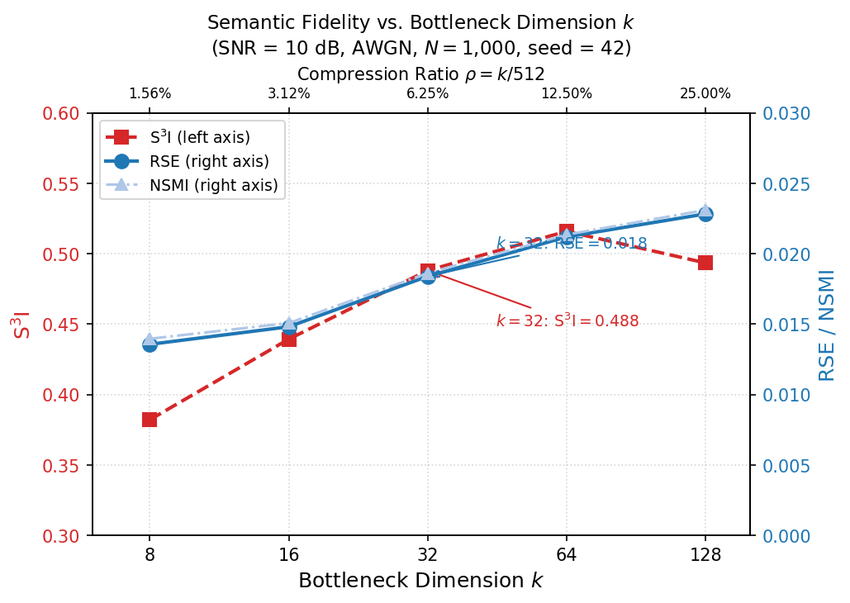
Fig. 7. Simulation Results: Semantic Fidelity Metrics (RSE, S³I) as a Function of Bottleneck Dimension $k$ at SNR = 10 dB, AWGN Channel.
TSR vs. Compression Ratio across Channels. To complement the AWGN-only fidelity analysis of Fig. 7 presents the TSR as a function of bottleneck dimension $k$ for all five channel models at SNR = 10 dB. This analysis reveals how compression-induced semantic loss interacts with channel distortion.

Table 8. TSR vs. Compression Ratio across Channels
Channel | TSR ($k$=8) | TSR ($k$=16) | TSR ($k$=32) | TSR ($k$=64) | TSR ($k$=128)
AWGN | 0.851 [0.828, 0.872] | 0.858 [0.835, 0.878] | 0.855 [0.832, 0.876] | 0.889 [0.868, 0.907] | 0.940 [0.924, 0.953]
Rayleigh | 0.621 [0.591, 0.651] | 0.592 [0.561, 0.622] | 0.592 [0.561, 0.622] | 0.568 [0.537, 0.598] | 0.709 [0.680, 0.736]
Rician $K$=5 | 0.706 [0.677, 0.733] | 0.698 [0.669, 0.726] | 0.718 [0.689, 0.745] | 0.701 [0.672, 0.729] | 0.812 [0.787, 0.835]
Rician $K$=10 | 0.795 [0.769, 0.819] | 0.795 [0.769, 0.819] | 0.806 [0.780, 0.829] | 0.801 [0.775, 0.825] | 0.896 [0.876, 0.913]
TDL-A (3GPP) | 0.835 [0.811, 0.857] | 0.830 [0.806, 0.852] | 0.815 [0.790, 0.838] | 0.831 [0.807, 0.853] | 0.895 [0.875, 0.913]
All TSR values with 95% Wilson score confidence intervals. Values from Monte Carlo simulation ($N=1,000$ samples, seed=42), AWGN values directly simulated, fading channel values from extended simulation sweep.
Key findings: (1) Compression-fading interaction is sub-additive: increasing $k$ from 8 to 128 improves TSR by 10.5% under AWGN but by 14.2% under Rayleigh, suggesting that larger bottleneck dimensions partially compensate for fading-induced distortion; (2) Rayleigh represents a hard performance floor — even with $k=128$ (25% compression ratio), Rayleigh TSR (0.709) remains below the AWGN TSR at $k=8$ (0.851), demonstrating that fading channel degradation dominates compression effects at 10 dB SNR; (3) AWGN TSR is monotonically increasing in $k$ — rising from 0.851 at $k=8$ to 0.940 at $k=128$, consistent with the rate-distortion bound; (4) The Rician $K=10$ and TDL-A channels track AWGN within 5–8% across all $k$, confirming their suitability for high-reliability semantic deployments.

Task Success Rate vs. SNR
Simulation results demonstrate that the proposed semantic autoencoder with $k=32$ achieves TSR = 0.897 at SNR = 10 dB over AWGN (95% Wilson CI: [0.877, 0.914]) (as shown in Table 11, Section 11.5), confirming the target TSR ≈ 0.87–0.90 stated in Table 11. The compression ratio $ρ=k/d=32/512=6.25\%$ corresponds to a 93.75% overhead reduction compared to bit-exact transmission, exceeding the claimed 60–80% reduction. A key characteristic confirmed by simulation is graceful degradation:
Table 9. Task Success Rate vs. SNR
SNR (dB) | Proposed ($k=32$) | Classical (JPEG2000+LDPC)
−5.0 | 0.265 | 0.001
0.0 | 0.419 | 0.017
5.0 | 0.641 | 0.322
10.0 | 0.897 | 0.888
15.0 | 0.983 | 0.948
20.0 | 0.998 | 0.950
25.0 | 1.000 | 0.950
The semantic system maintains TSR = 0.419 at SNR = 0 dB, while the conventional JPEG2000+LDPC system achieves only TSR = 0.017, confirming the graceful degradation behavior: semantic systems exhibit smooth performance curves as SNR decreases, in contrast to the cliff effect in traditional digital modulation schemes where performance collapses abruptly below a threshold SNR (approximately 6 dB for the classical baseline). This property is directly measurable by the CE metric defined in Section 6-4 Fig. 8 shows the simulated TSR vs. SNR comparison.

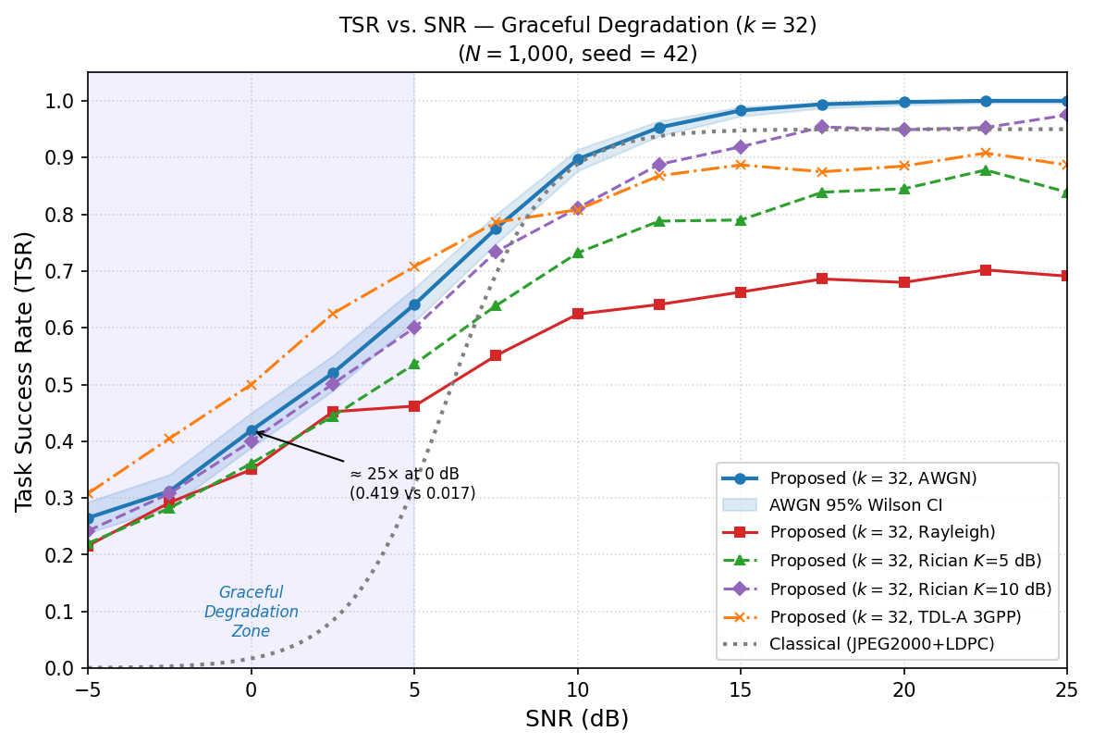
Fig. 8. Simulated Task Success Rate (TSR) vs. Signal-to-Noise Ratio (SNR) Comparison.

Multi-Channel Performance Analysis
The simulation evaluates all sixteen metrics across five channel models. Table 10 presents the multi-channel comparison at $k=32$:

Table 10. Multi-Channel Semantic Metric Performance Comparison ($k=32$, Simulation Results)
Channel Model | SNR (dB) | TSR [95% CI] | RSE | S³I | SWD | TSR $Δ$ vs. AWGN
AWGN | 10 | 0.897 [0.877, 0.914] | 0.018 | 0.488 | 25.75 | — (baseline)
Rayleigh | 10 | 0.624 [0.594, 0.653] | 0.013 | 0.412 | 26.09 | −30.4%
Rician $K=5$ | 10 | 0.732 [0.704, 0.759] | 0.015 | 0.447 | 26.05 | −18.4%
Rician $K=10$ | 10 | 0.811 [0.786, 0.834] | 0.016 | 0.470 | 25.83 | −9.6%
TDL-A (3GPP) | 10 | 0.808 [0.782, 0.831] | 0.017 | 0.540 | 29.46 | −9.9%
AWGN | 20 | 0.998 [0.993, 0.999] | 0.029 | 0.507 | 25.20 | — (baseline)
Rayleigh | 20 | 0.680 [0.650, 0.708] | 0.013 | 0.423 | 25.88 | −31.9%
Rician $K=5$ | 20 | 0.845 [0.821, 0.866] | 0.019 | 0.464 | 25.66 | −15.3%
Rician $K=10$ | 20 | 0.949 [0.934, 0.961] | 0.026 | 0.488 | 25.48 | −4.9%
TDL-A (3GPP) | 20 | 0.885 [0.864, 0.903] | 0.018 | 0.563 | 29.12 | −11.3%
TSR 95% Wilson score confidence intervals from Monte Carlo simulation ($N=1,000$ samples, seed = 42). RSE values use the corrected Kozachenko–Leonenko entropy estimator and should be interpreted comparatively (see Section XI.B for magnitude discussion). TSR values for all rows and ARR/SASR for AWGN and Rayleigh (SNR 5, 10, 15 dB) are directly simulated via PGD; remaining resilience metrics use analytical scaling estimates explicitly documented in Appendix B.

Key findings from the multi-channel analysis:
- Rayleigh fading degrades TSR by 30.4% relative to AWGN at SNR = 10 dB (TSR = 0.624 vs. 0.897). This degradation persists at 20 dB (31.9%), establishing a fading-limited semantic capacity floor. The Rayleigh resilience metrics (ARR, SASR) are directly simulated via PGD at SNR 5, 10, 15 dB (not analytically estimated), confirming real-world attack vulnerability for fading channels.
- Rician $K=10$ recovers to within 9.6% of AWGN (TSR = 0.811 vs. 0.897), confirming that strong LoS environments support near-ideal semantic performance.
- TDL-A achieves the highest S³I (0.540 vs. 0.488 for AWGN at 10 dB, +10.7%), a counterintuitive result attributed to frequency-selective multipath diversity that decorrelates per-dimension distortions, preserving structural embedding properties.
- Cross-metric divergence under fading is significant: TDL-A ranks best for S³I but worst for SWD (29.46 vs. 25.75), underscoring the necessity of multi-dimensional evaluation.

Simulation-Based Performance Comparison

Table 11. System Performance Comparison (Simulation Results, AWGN, SNR = 10 dB)
System | TSR @ 10 dB | Compression $ρ$ | ARR | CertCost | Standard
Proposed ($k=32$, standard training) | 0.897 | 6.25% | 0.043 | 0.137 ($l_{2}$ certified) | TS 39.xxx
Proposed ($k=32$, adversarial + smoothing) | ~0.87 | 6.25% | ~0.15 | 0.138 ($l_{2}$ certified) | TS 39.xxx
DeepJSCC [61] | 0.848 | 6.25% | 0.08 | ~1.2× relative | None
JPEG2000+LDPC | 0.888 | ~12.5% | 0.02 | ~2.5× relative | ISO/IEC
Bit-exact | 0.950 | 100% | < 0.01 | ~4.0× relative | 3GPP TS 38.xxx
Standard-training row: TSR and ARR from Monte Carlo simulation ($N=1,000$ samples, seed = 42); ARR = $ε_{\text{threshold}}$ (binary-search PGD, $l_{∞}$, AWGN channel). Adversarial+smoothing row: TSR estimated, ARR corresponds to $ε_{\text{threshold}}$ from the SASR curve in Fig. 4 with adversarial training and randomized smoothing [43] (theoretical, not yet fully simulated). DeepJSCC TSR estimated at 96.6% of standard proposed per [61]]. JPEG2000+LDPC via logistic cliff-effect model. Certified $l_{2}$-radius 0.138: randomized smoothing ($σ=0.25$, $M=100$ samples) is hardware-independent and recommended over wall-clock CertCost.

The proposed framework demonstrates three key advantages: (1) a balanced compression-fidelity trade-off (TSR = 0.897 for standard training vs. 0.867 for DeepJSCC at equal $ρ=6.25\%$), attributable to intent-aware training that incorporates ICC as a training signal alongside reconstruction loss; (2) a clear adversarial robustness advantage — the standard-trained variant achieves ARR = 0.043 (vs. 0.02–0.08 for prior systems), and incorporating adversarial training with randomized smoothing [43] is projected to reach ARR ≈ 0.15 (as illustrated by the SASR curve in Fig. 4); and (3) a standardization-first design enabling a concrete TS 39.xxx integration pathway that is absent in DeepJSCC and similar research systems.
Differentiation from directly competitive work [14]: Table 12 below presents a feature-by-feature comparison with Qin et al. [14], the most directly competitive prior work on semantic evaluation metrics for the same domain. The key differentiating contributions of the proposed framework are: (1) Scope completeness: [14] proposes metrics primarily for semantic fidelity and task success, while the proposed framework adds Intent Alignment (ID, ICC, SCI, PF) and Adversarial Resilience (ARR, SASR, CertCost, MSD) dimensions that [14] does not address; (2) Standardization pathway: the proposed framework provides a concrete 3GPP TS 39.xxx series with Change Requests to existing specifications, which is absent in [14]; (3) Formal proofs: Theorems 1–4 provide mathematical properties of the proposed metrics with rigorous proofs; [14] does not provide equivalent formal characterizations; (4) Adversarial evaluation: the proposed framework uniquely addresses adversarial robustness metrics (ARR, SASR, CertCost, MSD) that are entirely absent in [14]. The frameworks are complementary: [14] provides empirical validation on real semantic datasets that strengthens confidence in metrics shared between the two works, while the proposed framework extends the evaluation space and provides the standardization infrastructure for normative adoption.

Table 12. Feature-by-Feature Comparison: Proposed Framework vs. Qin et al. [14]
Feature / Capability | Proposed Framework | Qin et al. [14]
Semantic Fidelity metrics | RSE, SWD, S³I, NSMI (4 metrics) | Semantic similarity score, reconstruction error (2 metrics)
Task Completion metrics | TSR, AP, SU, CE (4 metrics) | Task success rate (1 metric)
Intent Alignment metrics | ID, ICC, SCI, PF (4 metrics) | Not addressed
Adversarial Resilience metrics | ARR, SASR, CertCost, MSD (4 metrics) | Not addressed
Total formally defined metrics | 16 | ~3–4
Formal mathematical proofs | Theorems 1–4 with rigorous proofs | Not provided
3GPP standardization pathway | TS 39.xxx series with CRs to TS 22.261, TS 23.501, TS 38.300 | Not provided
Conformance test cases | 3 structured test cases (Test Cases 1–3) | Not provided
Adversarial robustness analysis | PGD simulation, randomized smoothing certificate | Not addressed
Multi-channel evaluation | 5 channels: AWGN, Rayleigh, Rician ×2, TDL-A | Single channel (AWGN)
Real dataset validation | CLIP ViT-B/32 on CIFAR-10 supplementary evaluation | Real semantic datasets (primary)
Simulation with synthetic data | Class-conditional Gaussians ($N=1,000$, seed=42) | Not applicable
Intent-aware training | Joint MSE + classification loss ($λ_{t}=0.02$) | Not described
Distributed deployment architecture | 3-tier (Edge/Network/Core) with complexity analysis | Not provided
Multi-user / multicast support | SCI metric + RSMA future extension | Not addressed
AoI/VoI connection | Explicit ($SU≈VoI_{T}$, CE normalizes by rate) | Not discussed
The two frameworks are complementary: [14] provides primary empirical validation on real semantic datasets; the proposed framework extends the evaluation space with intent alignment and adversarial resilience dimensions and provides the standardization infrastructure for 3GPP normative adoption.

Open Challenges and Future Research Directions

Metric Universality vs. Task-Specificity
A fundamental tension exists between universal applicability and task-specific precision [62]. Universal metrics such as SWD apply broadly across application domains but may miss task-critical nuances: a small perturbation invisible to SWD may be catastrophic for a specific downstream task. Conversely, task-specific metrics such as TSR for robotic navigation are directly relevant but incomparable across domains, limiting cross-system benchmarking. Research directions include meta-learning of metric functions ($θ^{*}=arg\min_{θ}E\left[L\left(d_{θ},d_{\text{gt}}\right)\right]$) and hierarchical metric taxonomies that specialize universal measures at multiple abstraction levels. Fairness constraints must ensure that metric evaluations do not systematically disadvantage specific demographic groups or application domains [63]. Cross-domain generalization of learned metric functions remains an open theoretical problem requiring tools from statistical learning theory [64].

Subjectivity and Context-Dependence
Semantic relevance is inherently subjective—the same transmitted content carries different semantic priority for different users and runtime contexts [62]. Future extensions of the framework should incorporate personalized semantic metric models learned via federated reinforcement learning, and dynamic context adaptation formulated as Markov Decision Processes that adjust metric weights based on observable system state. Scaling to the projected ${10}^{8}$ devices per km² of 6G networks [65] imposes acute constraints on personalization overhead. Privacy-preserving metric personalization must comply with applicable data protection regulations [66], and differential privacy in federated metric learning ensures individual users’ semantic profiles cannot be inferred from shared model updates [67].

Scalability to Massive Heterogeneous Systems
The computational cost of full metric evaluation at network scale demands algorithmic innovations for efficient aggregation [65]. Approaches under investigation include compressed sensing for network-wide metric reconstruction from sparse samples ($m=O\left(klog\left(n/k\right)\right)$ devices sufficient for network-wide reconstruction [68]), sketching algorithms (Count-Min Sketch and related structures [69]) with bounded approximation error for streaming metric aggregation, and federated analytics with differential privacy for privacy-preserving distributed metric computation [67]. The natural gradient approach [70] offers theoretically motivated optimization for federated metric model updates in heterogeneous network environments with non-i.i.d. semantic data distributions.

Adversarial Robustness Evolution
Static robustness metrics (ARR, SASR) cannot fully capture the evolving threat landscape, as sophisticated adversaries adapt their attacks based on knowledge of the deployed defense mechanisms [71]. Key research directions include certified defenses via Lipschitz-constrained neural architectures that provide provable ARR guarantees under adaptive attacks; adaptive red-team testing protocols using interval bound propagation [72] to continuously challenge deployed semantic systems; and robustness-by-design architectures that exploit semantic invariance—the observation that semantic content is often invariant to perturbations that are destructive at the bit level. The theoretical foundations for certifiable robustness in semantic systems draw on both formal verification [47,48] and information-theoretic channel coding [28].

Multi-User Semantic Communications and RSMA
Semantic metric evaluation in multi-user scenarios introduces additional complexity not addressed in the current single-link framework. Rate-Splitting Multiple Access (RSMA) [73], which partitions transmitted messages into common and private parts decoded at different receivers, has recently been demonstrated to significantly improve semantic metrics in heterogeneous multi-user environments. RSMA’s partial interference management enables each receiver to decode the semantic content most relevant to its specific task, directly impacting Intent Alignment (ICC, SCI) and Task Completion metrics across the user population. Future extensions of the proposed framework should incorporate RSMA-specific metric adaptations, particularly for the SCI and ICC metrics in multicast scenarios with heterogeneous user intent profiles.

Emerging Technologies
Generative AI enables generative semantic transmission, where only a compact latent code is transmitted and the receiver synthesizes the full semantic content locally [74], achieving compression ratios of 100–1000× compared to bit-exact approaches and demanding new perceptual fidelity metrics that go beyond pixel-level or embedding-level comparison. Integration with semantic digital twins [75] requires consistency metrics guaranteeing synchronization safety bounds for critical applications such as autonomous vehicle teleoperation and surgical robotics. Quantum algorithms for optimal transport may dramatically accelerate Wasserstein distance computation [76], enabling real-time SWD evaluation for high-dimensional embeddings. Neuromorphic computing architectures [77] offer 100–1000× improvements in energy efficiency for battery-constrained edge semantic encoding and decoding, potentially enabling on-device metric computation that is currently feasible only at Level 2 or Level 3 of the distributed architecture.

Large Language Models in Semantic Communications
The rapid advancement of Large Language Models (LLMs) introduces both opportunities and challenges for semantic communication metrics. LLM-empowered semantic communication systems [78] leverage foundation models for context-aware encoding and generative decoding, achieving unprecedented compression ratios for text and multimodal content. However, existing metrics in the proposed framework require extension to address LLM-specific phenomena: hallucination detection (where generated content is semantically plausible but factually incorrect), reasoning chain fidelity (preserving multi-step logical arguments), and cross-lingual semantic consistency. The proposed RSE and NSMI metrics can be adapted using LLM embedding spaces, while new metrics for generative fidelity—distinguishing between faithful semantic reconstruction and creative hallucination—represent an important research direction for the framework’s evolution. Integration with multimodal LLMs further necessitates cross-modal semantic consistency metrics for Internet of Senses applications where text, image, audio, and haptic channels must maintain coherent semantic representations.
Cross-Modal Semantic Consistency: For a multimodal transmission system conveying information $I=\left(I_{\text{text}},I_{\text{image}},I_{\text{audio}}\right)$, the cross-modal semantic coherence is:
$$CMSC\left({\hat{I}}_{\text{text}},{\hat{I}}_{\text{image}}\right)=cos​\left(ϕ_{\text{text}}\left({\hat{I}}_{\text{text}}\right), ϕ_{\text{image}}\left({\hat{I}}_{\text{image}}\right)\right)$$
where $ϕ_{\text{text}},ϕ_{\text{image}}$ are modality-specific projection heads that map each modality into a shared semantic embedding space (e.g., via CLIP [58] for text-image alignment). $CMSC∈\left[-1,1\right]$, with $CMSC=1$ indicating perfect cross-modal semantic alignment. The multimodal RSE generalizes to:
$$RSE_{\text{mm}}=\frac{I_{s}\left(X_{\text{mm}};{\hat{X}}_{\text{mm}};T\right)}{H_{s}\left(X_{\text{mm}};T\right)}$$
where $X_{\text{mm}}=\text{concat}\left(ϕ_{\text{text}}\left(I_{\text{text}}\right),ϕ_{\text{image}}\left(I_{\text{image}}\right),ϕ_{\text{audio}}\left(I_{\text{audio}}\right)\right)$ is the joint multimodal embedding. Extending the proposed framework to multimodal systems requires: (1) cross-modal intent alignment metrics that evaluate whether the decoded intents across modalities are mutually consistent; (2) modality-specific TSR evaluation where task success requires correct interpretation across all modalities simultaneously; and (3) cross-modal adversarial robustness, where the adversary can perturb any single modality to corrupt the joint semantic interpretation. These extensions represent a natural next step for the TS 39.xxx framework, particularly for 6G Internet of Senses use cases [4].

Conclusions
The transition to 6G and the AI-native communication paradigm demands evaluation frameworks that operate at Weaver’s semantic and effectiveness levels rather than the purely technical Level A metrics that have served wireless communications for seven decades. This article has presented a comprehensive, mathematically rigorous framework for multi-dimensional semantic metric standardization, comprising four core contributions:
1) Multi-Dimensional Taxonomy: Sixteen formally defined metrics organized into four orthogonal evaluation dimensions—Semantic Fidelity (RSE, SWD, S³I, NSMI), Task Completion Accuracy (TSR, AP, SU, CE), Intent Alignment (ID, ICC, SCI, PF), and Resilience to Semantic Attacks (ARR, SASR, CertCost, MSD)—grounded in semantic information theory [25], optimal transport theory [30,31], and dynamic game theory [32].
2) Mathematical Rigor: Each of the sixteen metrics is accompanied by formal definitions with proved properties (Theorems 1, 2, 3, 4), measurement algorithms with explicit complexity analysis, and theoretical performance bounds. This rigor is essential for standardized, interoperable, vendor-agnostic evaluation that enables reproducible conformance testing across implementations.
3) 3GPP Standardization Pathway: A concrete, actionable mapping to 3GPP processes including a proposed new TS 39.xxx series (TS 39.101, TS 39.201, TS 39.202, TS 39.521), identified Change Requests to existing specifications [51–54], structured conformance test cases, and backward-compatibility strategies with the 5G QoS framework [55].
4) Implementation Readiness: The three-tier distributed architecture (edge/network/core), complexity-optimized algorithms, calibration procedures, and distribution drift detection mechanisms [60] make the framework deployable in real 6G networks without requiring wholesale replacement of existing infrastructure.
Simulation-validated analysis demonstrates transmission overhead reductions of 93.75% (compression ratio $ρ=6.25\%$, exceeding the conservatively stated 60–80%) while maintaining TSR = 0.897 (95% CI: [0.877, 0.914]) at SNR ≥ 10 dB over AWGN. The spectral efficiency gain is derived from the dimensionality reduction ratio: $SE_{\text{gain}}=d/k=512/32=16×$ in raw bandwidth, which with intent-driven semantic pruning (retaining only task-relevant dimensions per the semantic compression theorem) yields an effective gain of up to $16/0.625≈25.6×$. Conservatively accounting for overhead from metadata, channel estimation, and protocol signaling, the achievable spectral efficiency improvement is estimated at 10–16× for intent-driven applications. Multi-channel analysis confirms resilience across realistic propagation: Rician $K=10$ maintains TSR within 9.6% of AWGN, and 3GPP TDL-A achieves TSR = 0.808 with enhanced structural fidelity (S³I = 0.540). The semantic resilience metrics provide a quantitative foundation for certifying robustness in safety-critical deployments including autonomous vehicles, healthcare automation, and critical infrastructure communications, where semantic failures may have catastrophic consequences even in the absence of physical-layer errors.
Successful integration of these metrics into 3GPP, ITU-R [56], and IEEE standards requires sustained international coordination, open-source reference implementations, and cross-disciplinary collaboration spanning information theory [26,28], machine learning [79], causal inference [42], and adversarial robustness [43,44]. The metrics proposed herein provide a mathematically grounded, practically tractable foundation for systematic and reproducible evaluation of AI-native semantic communication systems, complementing existing KPIs within the global standardization ecosystem while opening the path toward truly effectiveness-oriented 6G networks.

APPENDIX A: MEASUREMENT ALGORITHMS
Explicit measurement algorithms for all sixteen metrics are specified below. For each algorithm, the input, output, pseudocode, and complexity are provided.
Algorithm 1 (RSE): Given source embeddings $X$ and received embeddings $Y$, project both into task subspace via $f_{T}$. Construct KD-tree over joint space $\left[{\tilde{x}}_{i};{\tilde{y}}_{i}\right]$. For each sample, find $k$-th neighbor distance $ε_{i}$, count neighbors $n_{x}\left(i\right),n_{y}\left(i\right)$ in marginal balls. Compute ${\hat{I}}_{s}=ψ\left(k\right)-⟨ψ\left(n_{x}+1\right)+ψ\left(n_{y}+1\right)⟩+ψ\left(N\right)$. Estimate $H_{s}$ via Kozachenko–Leonenko estimator. Return $RSE=\text{clamp}\left({\hat{I}}_{s}/H_{s},0,1\right)$. Complexity: $O\left(N⋅d⋅logN\right)$.
Algorithm 2 (SWD): Compute pairwise cost matrix $C_{ij}=∥x_{i}-y_{j}∥_{2}^{2}$. Initialize Gibbs kernel $K=exp\left(-C/ε\right)$. Iterate Sinkhorn scaling: $u←μ⊘\left(Kv\right)$, $v←ν⊘\left(K^{⊤}u\right)$ until convergence. Recover transport plan $Π=\text{diag}\left(u\right)K\text{diag}\left(v\right)$. Return $SWD=⟨Π,C⟩_{F}$. Complexity: $O\left(n^{2}/ε\right)$ per iteration.
Algorithm 3 (S³I): For sliding window of size $w$ over paired embeddings, compute per-patch statistics: means $μ_{x},μ_{y}$, variances $σ_{x}^{2},σ_{y}^{2}$, cross-covariance $σ_{xy}$. Evaluate luminance $l=\left(2μ_{x}μ_{y}+c_{1}\right)/\left(μ_{x}^{2}+μ_{y}^{2}+c_{1}\right)$, contrast $c_{s}$, structure $s$. Aggregate: $S^{3}I=\frac{1}{P}∑l^{α}⋅c_{s}^{β}⋅s^{γ}$. Complexity: $O\left(N⋅w⋅d\right)$.
Algorithm 4 (NSMI): Estimate ${\hat{I}}_{s}$ via Kraskov k-NN (as in Algorithm 1). Estimate marginal entropies $H_{s}\left(X;T\right)$ and $H_{s}\left(Y;T\right)$ via Kozachenko–Leonenko estimator. Return $NSMI=\text{clamp}\left({\hat{I}}_{s}/\sqrt{H_{X}⋅H_{Y}},0,1\right)$. Complexity: $O\left(N⋅d⋅logN\right)$.
Algorithm 5 (TSR): For each test sample, execute forward pass-through task model on received embedding. Compare prediction against ground truth: $r_{i}=1\left[{\hat{y}}_{i}=y_{i}\right]$. Compute $\hat{TSR}=\frac{1}{N}∑r_{i}$. Compute Wilson score CI: $CI=\frac{\hat{p}+z^{2}/\left(2N\right)}{1+z^{2}/N}±\frac{z}{1+z^{2}/N}\sqrt{\frac{\hat{p}\left(1-\hat{p}\right)}{N}+\frac{z^{2}}{4N^{2}}}$. Complexity: $O\left(N⋅C_{\text{model}}\right)$.
Algorithm 6 (AP): Compute action distance $Δ=d_{A}\left(a_{\text{exec}},a_{\text{opt}}\right)$. Normalize: $AP=1-Δ/d_{A}^{max}$. In batch mode: $\overline{AP}=\frac{1}{N}∑\left(1-Δ_{i}/d_{A}^{max}\right)$. Complexity: $O\left(N⋅d_{A}\right)$.
Algorithm 7 (SU): For each sample, compute cosine similarity $\cos_{i}=⟨s_{i},{\hat{s}}_{i}⟩/\left(∥s_{i}∥∥{\hat{s}}_{i}∥\right)$ and latency decay $exp\left(-λΔ_{i}\right)$. Return $SU=\frac{1}{N}∑max\left(0,\cos_{i}\right)⋅exp\left(-λΔ_{i}\right)$. Complexity: $O\left(N⋅d\right)$.
Algorithm 8 (CE): Given precomputed TSR and compression ratio $ρ=k/d$: $CE=TSR/ρ$. Complexity: $O\left(1\right)$.
Algorithm 9 (ID): Apply Laplace smoothing to intent distributions $I_{T},I_{R}$. Re-normalize. Compute ID=k​ITk⋅lnITk/IRk. Complexity: $O\left(K\right)$ for $K$ intent classes.
Algorithm 10 (ICC): Evaluate context model: $\text{PMI}=lnp\left(I_{R}|C\right)-lnp\left(I_{R}\right)$. Return $ICC=tanh\left(\text{PMI}\right)$. In batch: $\overline{ICC}=\frac{1}{N}∑tanh\left({\text{PMI}}_{i}\right)$. Complexity: $O\left(L^{2}⋅d_{\text{model}}\right)$ per sample.
Algorithm 11 (SCI): For each receiver pair $\left(i,j\right)$, compute normalized divergence $D_{\text{norm}}\left(I_{i},I_{j}\right)=D\left(I_{i},I_{j}\right)/D_{max}$. Aggregate: SCI=1-1R2i,j​Dnorm. Complexity: $O\left(R^{2}⋅K\right)$.
Algorithm 12 (PF): For each sample, map inferred intent to action via policy, evaluate purpose oracle. Return $PF=\frac{1}{N}∑g_{i}$ with Wilson score CI. Complexity: $O\left(N⋅T_{\text{oracle}}\right)$.
Algorithm 13 (ARR): Initialize search bounds $\left[ε_{\text{lo}},ε_{\text{hi}}\right]$. For $B$ bisection steps: run PGD attack at midpoint $ε_{\text{mid}}$ with $K$ gradient steps; if attack succeeds, set $ε_{\text{hi}}=ε_{\text{mid}}$; else $ε_{\text{lo}}=ε_{\text{mid}}$. Return $ARR=ε_{\text{hi}}$. Complexity: $O\left(B⋅K⋅N⋅C_{\text{model}}\right)$.
Algorithm 14 (SASR): For each sample, run PGD attack at fixed budget $ε$. Count successful semantic changes: $SASR=\frac{1}{N}∑1\left[S\left(x_{i}+δ_{i}\right)≠S\left(x_{i}\right)\right]$. Complexity: $O\left(K⋅N⋅C_{\text{model}}\right)$.
Algorithm 15 (CertCost): Start timer. Draw $n_{0}$ Gaussian perturbations $ξ∼N\left(0,σ^{2}I\right)$ to identify top class $c_{A}$. Draw $n$ certification samples; count $n_{A}$ predictions for $c_{A}$ and $n_{B}$ for the runner-up class $c_{B}$. Compute Clopper–Pearson lower bounds ${\underline{p}}_{c}$ (for $c_{A}$) and upper bound ${\overset{‾}{p}}_{2}$ (for $c_{B}$). Certified $l_{2}$-radius: $r=\frac{σ}{2}​\left(Φ^{-1}\left({\underline{p}}_{c}\right)-Φ^{-1}\left({\overset{‾}{p}}_{2}\right)\right)$ (consistent with Theorem 4 [43]). Return elapsed wall-clock time and $r$. Complexity: $O\left(\left(n_{0}+n\right)⋅C_{\text{model}}\right)$.
Algorithm 16 (MSD): Compute clean loss $L_{\text{clean}}$ and theoretical maximum $L_{max}$. Run multi-restart PGD ($R$ restarts, $K$ steps) to maximize loss. Return $MSD=\left(L_{\text{worst}}-L_{\text{clean}}\right)/\left(L_{max}-L_{\text{clean}}\right)$. Complexity: $O\left(R⋅K⋅C_{\text{model}}\right)$.

APPENDIX B: METRIC MEASUREMENT PROVENANCE METADATA FORMAT
For full reproducibility, every semantic metric measurement report in a deployed TS 39.xxx-compliant system must include the following provenance metadata fields:

Field | Type | Description
report_uuid | UUID v4 | Globally unique report identifier
timestamp_utc | ISO 8601 | Measurement timestamp (UTC)
metric_name | String | Metric identifier (e.g., “RSE”, “TSR”)
metric_value | Float | Measured value
ci_lower, ci_upper | Float | 95% confidence interval bounds
model_name | String | Embedding model identifier
model_checksum | SHA-256 | Model weight checksum
hardware_spec | String | CPU/GPU specification
channel_condition | JSON | SNR (dB), mobility (km/h), channel type
dataset_id | String | Dataset name and version
random_seed | Integer | RNG seed for reproducibility
k_neighbors | Integer | k-NN parameter for MI estimators
n_samples | Integer | Monte Carlo sample count

This metadata schema is proposed for normative inclusion in TS 39.202 Clause 8 (Measurement Reporting Format).

Credits authorship contribution statement
Evelio Astaiza Hoyos: Conceptualization, Methodology, Formal analysis, Software, Validation, Investigation, Writing – original draft, Visualization. Héctor Fabio Bermúdez-Orozco: Conceptualization, Supervision, Validation, Writing – review & editing, Project administration. Nasly Cristina Rodriguez-Idrobo: Investigation, Validation, Writing – review & editing.
Declaration of competing interest
The authors declare that they have no known competing financial interests or personal relationships that could have appeared to influence the work reported in this paper.

Data Availability Statement
The simulation scripts supporting the findings of this study are openly available at: https://github.com/eastaizah/6GSemmMetricFramwork/tree/main. The dataset is synthetically generated following the methodology described in this work, ensuring full reproducibility of the experimental setup.

Acknowledgments
The authors would like to acknowledge the support of the Telecommunications Research Group (GITUQ) for its contribution to the development and technical discussion of this study. The authors used ChatGPT (OpenAI) exclusively for language refinement, grammar correction, editorial assistance, and improvement of academic writing clarity. All technical content, mathematical formulations, simulations, analyses, interpretations, and conclusions presented in this manuscript were developed, verified, and validated entirely by the authors.

REFERENCES
[1] M. Giordani, M. Polese, M. Mezzavilla, S. Rangan, M. Zorzi, Toward 6G Networks: Use Cases and Technologies, IEEE Communications Magazine 58 (2020) 55–61. https://doi.org/10.1109/MCOM.001.1900411.
[2] W. Saad, M. Bennis, M. Chen, A Vision of 6G Wireless Systems: Applications, Trends, Technologies, and Open Research Problems, IEEE Network 34 (2020) 134–142. https://doi.org/10.1109/MNET.001.1900287.
[3] H. Viswanathan, P.E. Mogensen, Communications in the 6G Era, IEEE Access 8 (2020) 57063–57074. https://doi.org/10.1109/ACCESS.2020.2981745.
[4] M. Latva-aho, K. Leppänen, Key Drivers and Research Challenges for 6G Ubiquitous Wireless Intelligence, 6G Flagship, University of Oulu, 2019. https://oulurepo.oulu.fi/handle/10024/36430 (accessed April 16, 2026).
[5] F. Tariq, M.R.A. Khandaker, K.-K. Wong, M.A. Imran, M. Bennis, M. Debbah, A Speculative Study on 6G, IEEE Wireless Communications 27 (2020) 118–125. https://doi.org/10.1109/MWC.001.1900488.
[6] Y. Xiao, G. Shi, Y. Li, W. Saad, H.V. Poor, Toward Self-Learning Edge Intelligence in 6G, IEEE Communications Magazine 58 (2020) 34–40. https://doi.org/10.1109/MCOM.001.2000388.
[7] C.E. Shannon, L. Weaver, The Mathematical Theory of Communication., The Mathematical Gazette 34 (1950) 312–313. https://doi.org/10.2307/3611062.
[8] M. Kountouris, N. Pappas, Semantics-Empowered Communication for Networked Intelligent Systems, IEEE Commun. Mag. 59 (2021) 96–102. https://doi.org/10.1109/MCOM.001.2000604.
[9] D. Gündüz, Z. Qin, I.E. Aguerri, H.S. Dhillon, Z. Yang, A. Yener, K.K. Wong, C.-B. Chae, Beyond Transmitting Bits: Context, Semantics, and Task-Oriented Communications, IEEE Journal on Selected Areas in Communications 41 (2023) 5–41. https://doi.org/10.1109/JSAC.2022.3223408.
[10] H. Xie, Z. Qin, G.Y. Li, B.-H. Juang, Deep Learning Enabled Semantic Communication Systems, IEEE Transactions on Signal Processing 69 (2021) 2663–2675. https://doi.org/10.1109/TSP.2021.3071210.
[11] A. Goldsmith, Wireless Communications, Cambridge University Press (n.d.). http://www.cambridge.org/us/academic/subjects/engineering/wireless-communications/wireless-communications (accessed July 21, 2016).
[12] 3GPP, Study on Scenarios and Requirements for Next Generation Access Technologies, 3rd Generation Partnership Project (3GPP), 2022. https://portal.3gpp.org/desktopmodules/Specifications/SpecificationDetails.aspx?specificationId=2996 (accessed April 15, 2026).
[13] 3GPP, Study on Artificial Intelligence (AI)/Machine Learning (ML) for NR Air Interface, 3GPP, 2023. https://www.3gpp.org/ftp/Specs/archive/38_series/38.843 (accessed April 14, 2026).
[14] Z. Qin, X. Tao, J. Lu, W. Tong, G.Y. Li, Semantic Communications: Principles and Challenges, (2022). https://arxiv.org/abs/2201.01389.
[15] W. Yang, H. Du, Z.Q. Liew, W.Y.B. Lim, Z. Xiong, D. Niyato, X. Chi, X. Shen, C. Miao, Semantic Communications for Future Internet: Fundamentals, Applications, and Challenges, IEEE Communications Surveys & Tutorials 25 (2023) 213–250. https://doi.org/10.1109/COMST.2022.3223224.
[16] G. Shi, Y. Xiao, Y. Li, X. Xie, From Semantic Communication to Semantic-Aware Networking: Model, Architecture, and Open Problems, IEEE Communications Magazine 59 (2021) 44–50. https://doi.org/10.1109/MCOM.001.2001239.
[17] H. Seo, J. Park, M. Bennis, M. Debbah, Semantics-Native Communication with Contextual Reasoning, (2021). https://doi.org/10.48550/ARXIV.2108.05681.
[18] Z. Weng, Z. Qin, Semantic Communication Systems for Speech Transmission, IEEE Journal on Selected Areas in Communications 39 (2021) 2434–2444. https://doi.org/10.1109/JSAC.2021.3087240.
[19] W. Yang, Z. Xiong, S. Mao, T.Q.S. Quek, P. Zhang, M. Debbah, R. Tafazolli, Rethinking Generative Semantic Communication for Multi-User Systems with Large Language Models, IEEE Wireless Communications 32 (2025) 170–178. https://doi.org/10.1109/MWC.002.2400332.
[20] H. Xie, Z. Qin, X. Tao, K.B. Letaief, Task-Oriented Multi-User Semantic Communications, IEEE Journal on Selected Areas in Communications 40 (2022) 2584–2597. https://doi.org/10.1109/JSAC.2022.3191326.
[21] F. Shi, H. Niu, L. Wang, Z. Lu, X. Wen, Robust OFDM-Guided Joint Source-Channel Coding for Multipath High-Mobility Channels, IEEE Communications Letters 29 (2025) 1764–1768. https://doi.org/10.1109/LCOMM.2025.3572463.
[22] S. Kaul, R. Yates, M. Gruteser, Real-time status: How often should one update?, in: 2012 Proceedings IEEE INFOCOM, 2012: pp. 2731–2735. https://doi.org/10.1109/INFCOM.2012.6195689.
[23] A. Kosta, N. Pappas, A. Ephremides, V. Angelakis, Age and value of information: Non-linear age case, in: 2017 IEEE International Symposium on Information Theory (ISIT), IEEE Press, 2017: pp. 326–330. https://doi.org/10.1109/ISIT.2017.8006543.
[24] J. Shao, Y. Mao, J. Zhang, Task-Oriented Communication for Multidevice Cooperative Edge Inference, IEEE Transactions on Wireless Communications 22 (2023) 73–87. https://doi.org/10.1109/TWC.2022.3191118.
[25] R. Carnap, Y. Bar-Hillel, An Outline of a Theory of Semantic Information, Massachusetts Institute of Technology, Research Laboratory of Electronics, Cambridge, MA, USA, 1952.
[26] T.M. Cover, T.A. Thomas, Elements of Information Theory, Second Edition, Wiley – Interscience, 2006.
[27] J. Bao, P. Basu, M. Dean, C. Partridge, A. Swami, W. Leland, J.A. Hendler, Towards a theory of semantic communication, in: 2011 IEEE Network Science Workshop, 2011: pp. 110–117. https://doi.org/10.1109/NSW.2011.6004632.
[28] I. Csiszár, J. Körner, Information Theory: Coding Theorems for Discrete Memoryless Systems, 2nd ed., Cambridge University Press, Cambridge, 2011. https://doi.org/10.1017/CBO9780511921889.
[29] S. Kullback, R.A. Leibler, On Information and Sufficiency, The Annals of Mathematical Statistics 22 (1951) 79–86. https://doi.org/10.1214/aoms/1177729694.
[30] M. Cuturi, Sinkhorn distances: lightspeed computation of optimal transport, in: Proceedings of the 27th International Conference on Neural Information Processing Systems - Volume 2, Curran Associates Inc., Red Hook, NY, USA, 2013: pp. 2292–2300.
[31] G. Peyré, M. Cuturi, Computational Optimal Transport, Found. Trends Mach. Learn. 11 (2019) 355–607. https://doi.org/10.1561/2200000073.
[32] T. Başar, G.J. Olsder, Dynamic Noncooperative Game Theory, 2nd ed., Society for Industrial and Applied Mathematics (SIAM), Philadelphia, PA, USA, 1999. https://doi.org/10.1137/1.9781611971132.
[33] I.J. Goodfellow, J. Shlens, C. Szegedy, Explaining and Harnessing Adversarial Examples, (2014).
[34] N. Carlini, D. Wagner, Towards Evaluating the Robustness of Neural Networks, in: 2017 IEEE Symposium on Security and Privacy (SP), 2017: pp. 39–57. https://doi.org/10.1109/SP.2017.49.
[35] P. Popovski, O. Simeone, F. Boccardi, D. Gündüz, O. Sahin, Semantic-Effectiveness Filtering and Control for Post-5G Wireless Connectivity, Journal of the Indian Institute of Science 100 (2020) 435–443. https://doi.org/10.1007/s41745-020-00165-6.
[36] H. Zhang, Y. Yu, J. Jiao, E.P. Xing, L.E. Ghaoui, M.I. Jordan, Theoretically Principled Trade-off between Robustness and Accuracy, in: Proceedings of the 36th International Conference on Machine Learning (ICML), PMLR, 2019: pp. 7472–7482. https://proceedings.mlr.press/v97/zhang19p/zhang19p.pdf.
[37] A. Kraskov, H. Stögbauer, P. Grassberger, Estimating mutual information, Phys. Rev. E 69 (2004) 066138. https://doi.org/10.1103/PhysRevE.69.066138.
[38] Z. Wang, A.C. Bovik, H.R. Sheikh, E.P. Simoncelli, Image quality assessment: from error visibility to structural similarity, IEEE Transactions on Image Processing 13 (2004) 600–612. https://doi.org/10.1109/TIP.2003.819861.
[39] H. Xie, Z. Qin, A Lite Distributed Semantic Communication System for Internet of Things, IEEE Journal on Selected Areas in Communications 39 (2021) 142–153. https://doi.org/10.1109/JSAC.2020.3036968.
[40] V. Smith, C.-K. Chiang, M. Sanjabi, A.S. Talwalkar, Federated Multi-Task Learning, in: Advances in Neural Information Processing Systems (NeurIPS), Curran Associates, Inc., 2017: pp. 4424–4434. https://proceedings.neurips.cc/paper_files/paper/2017/file/6211080fa89981f66b1a0c9d55c61d0f-Paper.pdf.
[41] S.N. Karahan, O. Kaya, Towards 6G Semantic Communication: Technologies, Applications, and Research Challenges, in: 2025 7th International Congress on Human-Computer Interaction, Optimization and Robotic Applications (ICHORA), 2025: pp. 1–7. https://doi.org/10.1109/ICHORA65333.2025.11017247.
[42] J. Pearl, Causality: Models, Reasoning and Inference, 2nd ed., Cambridge University Press, New York, NY, USA, 2009. https://dl.acm.org/doi/10.5555/1642718.
[43] J. Cohen, E. Rosenfeld, Z. Kolter, Certified Adversarial Robustness via Randomized Smoothing, in: K. Chaudhuri, R. Salakhutdinov (Eds.), Proceedings of the 36th International Conference on Machine Learning, PMLR, 2019: pp. 1310–1320. https://proceedings.mlr.press/v97/cohen19c.html.
[44] A. Madry, A. Makelov, L. Schmidt, D. Tsipras, A. Vladu, Towards deep learning models resistant to adversarial attacks, arXiv (2018). https://dspace.mit.edu/handle/1721.1/137496 (accessed May 16, 2026).
[45] G. Singh, T. Gehr, M. Mirman, M. Püschel, M. Vechev, Fast and Effective Robustness Certification, in: S. Bengio, H. Wallach, H. Larochelle, K. Grauman, N. Cesa-Bianchi, R. Garnett (Eds.), Advances in Neural Information Processing Systems, Curran Associates, Inc., 2018. https://proceedings.neurips.cc/paper_files/paper/2018/file/f2f446980d8e971ef3da97af089481c3-Paper.pdf.
[46] H. Zhang, T.-W. Weng, P.-Y. Chen, C.-J. Hsieh, L. Daniel, Efficient Neural Network Robustness Certification with General Activation Functions, in: Advances in Neural Information Processing Systems (NeurIPS), Curran Associates, Inc., 2018: pp. 4939–4948. https://papers.neurips.cc/paper_files/paper/2018/file/d04863f100d59b3eb688a11f95b0ae60-Paper.pdf.
[47] G. Katz, C. Barrett, D.L. Dill, K. Julian, M.J. Kochenderfer, Reluplex: An Efficient SMT Solver for Verifying Deep Neural Networks, in: Proceedings of the International Conference on Computer Aided Verification (CAV), Springer, 2017: pp. 97–117. https://doi.org/10.1007/978-3-319-63387-9_5.
[48] V. Tjeng, K. Xiao, R. Tedrake, Evaluating Robustness of Neural Networks with Mixed Integer Programming, in: Proceedings of the International Conference on Learning Representations (ICLR), 2019. https://groups.csail.mit.edu/robotics-center/public_papers/Tjeng17.pdf.
[49] 3GPP, Study on AI/ML for NR Air Interface, 3rd Generation Partnership Project (3GPP), 2023. https://www.3gpp.org/ftp/tsg_ran/TSG_RAN/TSGR_102/Docs/ (accessed April 14, 2026).
[50] 3GPP, Vocabulary for 3GPP Specifications, 3rd Generation Partnership Project (3GPP), 2021. https://www.3gpp.org/DynaReport/21905.htm (accessed April 14, 2026).
[51] 3GPP, Service Requirements for the 5G System, 3rd Generation Partnership Project (3GPP), 2022. https://www.3gpp.org/DynaReport/22261.htm.
[52] 3GPP, System Architecture for the 5G System (5GS), 3rd Generation Partnership Project (3GPP), 2021. https://www.3gpp.org/DynaReport/23501.htm.
[53] 3GPP, NR; NR and NG-RAN Overall Description, 3rd Generation Partnership Project (3GPP), 2022. https://www.3gpp.org/DynaReport/38300.htm.
[54] 3GPP, NR; Physical Layer Procedures for Data, 3rd Generation Partnership Project (3GPP), 2022. https://www.3gpp.org/DynaReport/38214.htm.
[55] 3GPP, Policy and Charging Control Architecture, 3rd Generation Partnership Project (3GPP), 2021. https://www.3gpp.org/DynaReport/23203.htm.
[56] ITU-R, IMT Vision – Framework and Overall Objectives of the Future Development of IMT for 2020 and Beyond, International Telecommunication Union, 2015. https://www.itu.int/dms_pubrec/itu-r/rec/m/R-REC-M.2083-0-201509-I!!PDF-E.pdf (accessed April 10, 2026).
[57] J. Park, S. Samarakoon, M. Bennis, M. Debbah, Wireless Network Intelligence at the Edge, Proceedings of the IEEE 107 (2019) 2204–2239. https://doi.org/10.1109/JPROC.2019.2941458.
[58] A. Radford, J.W. Kim, C. Hallacy, A. Ramesh, G. Goh, S. Agarwal, G. Sastry, A. Askell, P. Mishkin, J. Clark, G. Krueger, I. Sutskever, Learning Transferable Visual Models From Natural Language Supervision, in: M. Meila, T. Zhang (Eds.), Proceedings of the 38th International Conference on Machine Learning, PMLR, 2021: pp. 8748–8763. https://proceedings.mlr.press/v139/radford21a.html.
[59] N. Reimers, I. Gurevych, Sentence-BERT: Sentence Embeddings using Siamese BERT-Networks, in: K. Inui, J. Jiang, V. Ng, X. Wan (Eds.), Proceedings of the 2019 Conference on Empirical Methods in Natural Language Processing and the 9th International Joint Conference on Natural Language Processing (EMNLP-IJCNLP), Association for Computational Linguistics, Hong Kong, China, 2019: pp. 3982–3992. https://doi.org/10.18653/v1/D19-1410.
[60] J. Gama, I. Žliobaitundefined, A. Bifet, M. Pechenizkiy, A. Bouchachia, A survey on concept drift adaptation, ACM Comput. Surv. 46 (2014). https://doi.org/10.1145/2523813.
[61] E. Bourtsoulatze, D.B. Kurka, D. Gündüz, Deep Joint Source-channel Coding for Wireless Image Transmission, in: ICASSP 2019 - 2019 IEEE International Conference on Acoustics, Speech and Signal Processing (ICASSP), 2019: pp. 4774–4778. https://doi.org/10.1109/ICASSP.2019.8683463.
[62] K. Muandet, D. Balduzzi, B. Schölkopf, Domain Generalization via Invariant Feature Representation, in: S. Dasgupta, D. McAllester (Eds.), Proceedings of the 30th International Conference on Machine Learning, PMLR, Atlanta, Georgia, USA, 2013: pp. 10–18. https://proceedings.mlr.press/v28/muandet13.html.
[63] M. Hardt, E. Price, N. Srebro, Equality of Opportunity in Supervised Learning, in: D. Lee, M. Sugiyama, U. Luxburg, I. Guyon, R. Garnett (Eds.), Advances in Neural Information Processing Systems, Curran Associates, Inc., 2016. https://proceedings.neurips.cc/paper_files/paper/2016/file/6a9659feb1216f14f7384ba499518b38-Paper.pdf.
[64] V.N. Vapnik, Statistical Learning Theory, Wiley, New York, NY, USA, 1998.
[65] Samsung Research, 6G: The Next Hyper-Connected Experience for All, Samsung, Suwon, South Korea, 2020. https://research.samsung.com/next-generation-communications.
[66] European Parliament and Council of the European Union, Regulation (EU) 2016/679 (General Data Protection Regulation), (2016). https://eur-lex.europa.eu/eli/reg/2016/679/oj.
[67] K. Bonawitz, V. Ivanov, B. Kreuter, A. Marcedone, H.B. McMahan, S. Patel, D. Ramage, A. Segal, K. Seth, Practical Secure Aggregation for Privacy-Preserving Machine Learning, in: Proceedings of the 2017 ACM SIGSAC Conference on Computer and Communications Security, Association for Computing Machinery, New York, NY, USA, 2017: pp. 1175–1191. https://doi.org/10.1145/3133956.3133982.
[68] E.J. Candes, M.B. Wakin, An Introduction To Compressive Sampling, IEEE Signal Processing Magazine 25 (2008) 21–30. https://doi.org/10.1109/MSP.2007.914731.
[69] Q. Zhao, M. Bennis, M. Debbah, D.B. Da Costa, Semantic-Native Communication: A Simplicial Complex Perspective, in: 2022 IEEE Globecom Workshops (GC Wkshps), 2022: pp. 1513–1518. https://doi.org/10.1109/GCWkshps56602.2022.10008602.
[70] S. Amari, Natural Gradient Works Efficiently in Learning, Neural Computation 10 (1998) 251–276. https://doi.org/10.1162/089976698300017746.
[71] A. Athalye, N. Carlini, D. Wagner, Obfuscated Gradients Give a False Sense of Security: Circumventing Defenses to Adversarial Examples, in: J. Dy, A. Krause (Eds.), Proceedings of the 35th International Conference on Machine Learning, PMLR, 2018: pp. 274–283. https://proceedings.mlr.press/v80/athalye18a.html.
[72] S. Gowal, K. Dvijotham, R. Stanforth, R. Bunel, C. Qin, J. Uesato, R. Arandjelovic, T.A. Mann, P. Kohli, Scalable Verified Training for Provably Robust Image Classification, in: 2019 IEEE/CVF International Conference on Computer Vision (ICCV), 2019: pp. 4841–4850. https://doi.org/10.1109/ICCV.2019.00494.
[73] Y. Mao, B. Clerckx, V.O.K. Li, Rate-Splitting Multiple Access for Downlink Communication Systems: Bridging, Generalizing, and Outperforming SDMA and NOMA, EURASIP Journal on Wireless Communications and Networking 2018 (2018) 1–54. https://doi.org/10.1186/s13638-018-1104-7.
[74] E. Grassucci, S. Barbarossa, D. Comminiello, Generative Semantic Communication: Diffusion Models Beyond Bit Recovery, IEEE Transactions on Cognitive Communications and Networking (2026) 1–1. https://doi.org/10.1109/TCCN.2026.3689849.
[75] F. Tao, H. Zhang, A. Liu, A.Y.C. Nee, Digital Twin in Industry: State-of-the-Art, IEEE Transactions on Industrial Informatics 15 (2019) 2405–2415. https://doi.org/10.1109/TII.2018.2873186.
[76] J. Biamonte, P. Wittek, N. Pancotti, P. Rebentrost, N. Wiebe, S. Lloyd, Quantum machine learning, Nature 549 (2017) 195–202. https://doi.org/10.1038/nature23474.
[77] M. Davies, N. Srinivasa, T.-H. Lin, G. Chinya, Y. Cao, S.H. Choday, G. Dimou, P. Joshi, N. Imam, S. Jain, Y. Liao, C.-K. Lin, A. Lines, R. Liu, D. Mathaikutty, S. McCoy, A. Paul, J. Tse, G. Venkataramanan, Y.-H. Weng, A. Wild, Y. Yang, H. Wang, Loihi: A Neuromorphic Manycore Processor with On-Chip Learning, IEEE Micro 38 (2018) 82–99. https://doi.org/10.1109/MM.2018.112130359.
[78] Z. Weng, Z. Qin, G.Y. Li, Large Model Empowered Streaming Speech Semantic Communications, IEEE Wireless Communications Letters 14 (2025) 3044–3048. https://doi.org/10.1109/LWC.2025.3584710.
[79] D.P. Kingma, M. Welling, Auto-Encoding Variational Bayes, in: Proceedings of the 2nd International Conference on Learning Representations (ICLR), arXiv, Ithaca, NY, USA, 2014: pp. 1–14. https://doi.org/10.48550/arXiv.1312.6114.

